ST JOHN’S URC CHURCH MARSH GREEN
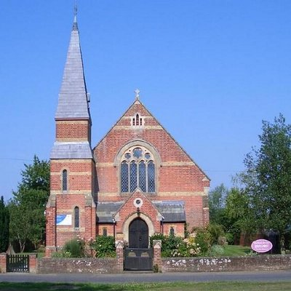
CHRISTMAS 2020 NEWSLETTER

INTRODUCTION

Welcome to the Christmas 2020 edition of the St John’s Marsh Green church newsletter. This newsletter appears 3 times a year – before Christmas, before Easter and before Harvest. As well as church news and views we invite contributions from church members and local people, whether about people, events, local history, topical issues, or anything else on which you want to have your say.

MINISTER’S LETTER

Dear Friends
We are coming to the end of one of the strangest years that I can ever remember. It has, at times, seemed a little like riding a fairground roller coaster. One moment climbing up into the sky and the next moment plunging back down again. Closing the church at one moment, reopening after a time only to have to close it again and then after another period to reopen it again. Very strange times indeed!
But even if we have been unable to rely on the “norm” any longer we still have the constancy of God’s love. We have entered the period of Advent and we are once again enjoying the preparation for one of the greatest of Christian festivals, the story of God coming down to live amongst men, sharing the joys but also the sorrows. But he came not as a king but as a helpless babe. It is a story which is old yet also new, especially to the young ones growing up amongst us.
Now for the second time this year we are able to open our churches, yet again, so that we can celebrate Advent and Christmas. But, and it is a very large but, we must remember there are many of our congregation and our community who feel unable, because of age and illness, to return to church yet or indeed to leave their houses. This pandemic has caused a huge tide of loneliness in our communities and in our gladness at the release of the vaccine for the virus we must remember that many will not feel able to live in the same way as they have done before. This scourge of loneliness will not go away on its own. We, as we rejoice in the message of Christmas, must be sensitive to those who feel that they cannot join in.
Christ came for the lonely and rejected and so we must remember all those around us in whatever circumstance they are. So, as we rejoice we must remember that it was to the shepherds, the marginalised in society, that the Christ child was first revealed. Let us enjoy the holiday period but also pray, not necessarily for a return to the old “norm”, but for freedom to be able to move on in whatever way God is directing us.
I close with a heartfelt wish that everyone will have a peaceful Christmas as we return once again to worship at the manger.
With every blessing

Yours in Christ

Graham

Revd Graham Dadd
graham_dadd@yahoo.co.uk
Church Secretary
Elizabeth Richmond
richmondshire@btinternet.comTel: 01732 863368

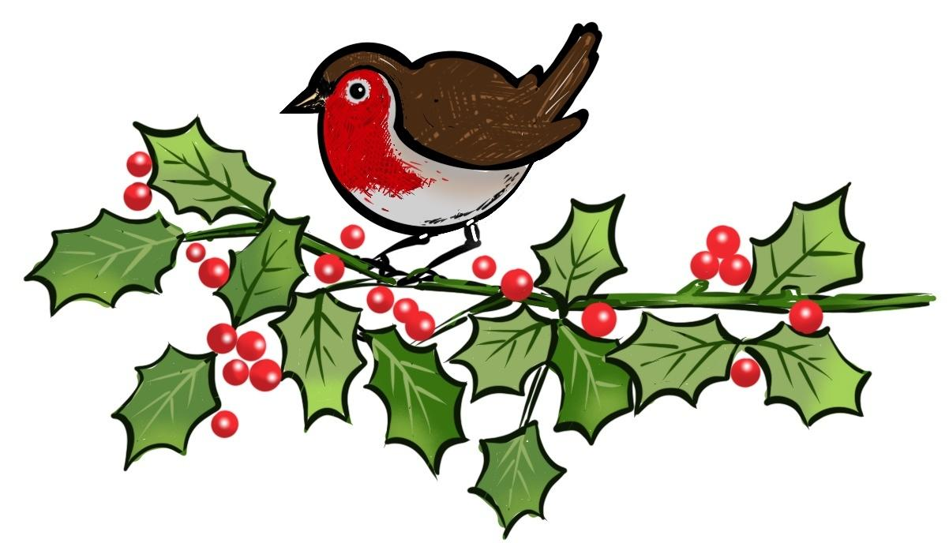

SERVICES IN DECEMBER

13th at 10.30 am Worship with Communion led by the Minister

20th at 10.30 am ‘The Christmas Story’ led by Jean Gibbons

24th at 6.30 pm Carol Service on the Green

25th at 10.30 am A short service for Christmas Day led by the Minister

27th at 10.30 am ‘Looking forward with hope’ led by Jean Gibbons

We have had to adapt our services to what is possible this year but the Christmas message remains the same.

On December 20th the children are unable to act in the Nativity Service in the usual way because of safe distancing but we shall still hear the Christmas story, relying on video clips and music to bring it to life again in a new way, involving children, young people and adults.

The Carol Service posed a different problem because the church would not be able to accommodate the large congregation that we have been used to – and we wouldn’t be able to sing. But we are now allowed to sing outside. So, our service will be led from the church steps with the congregation well spaced standing on the green. (If you wish to sit please bring your own chair.) Of course we don’t know what the weather will be like but we can dress appropriately and, whatever the conditions, together will be able to hear again the Christmas message and sing much loved carols. The service will be shorter than usual and those coming are asked to observe all the covid regulations – which sadly prevent us serving mince pies after the service.

On Christmas Day, our service will follow the usual pattern. Unless numbers are much higher than usual we should be able to fit everyone in but, if you can, please reserve a seat with Elizabeth the day before.

With the good news of the birth of Jesus, we look forward with hope in the service on December 27th.

SERVICES IN JANUARY
3rd tba
10th Worship with Communion led by the Minister
17th Worship led by Revd David Flagg
24th Worship led by Revd Martin Hazell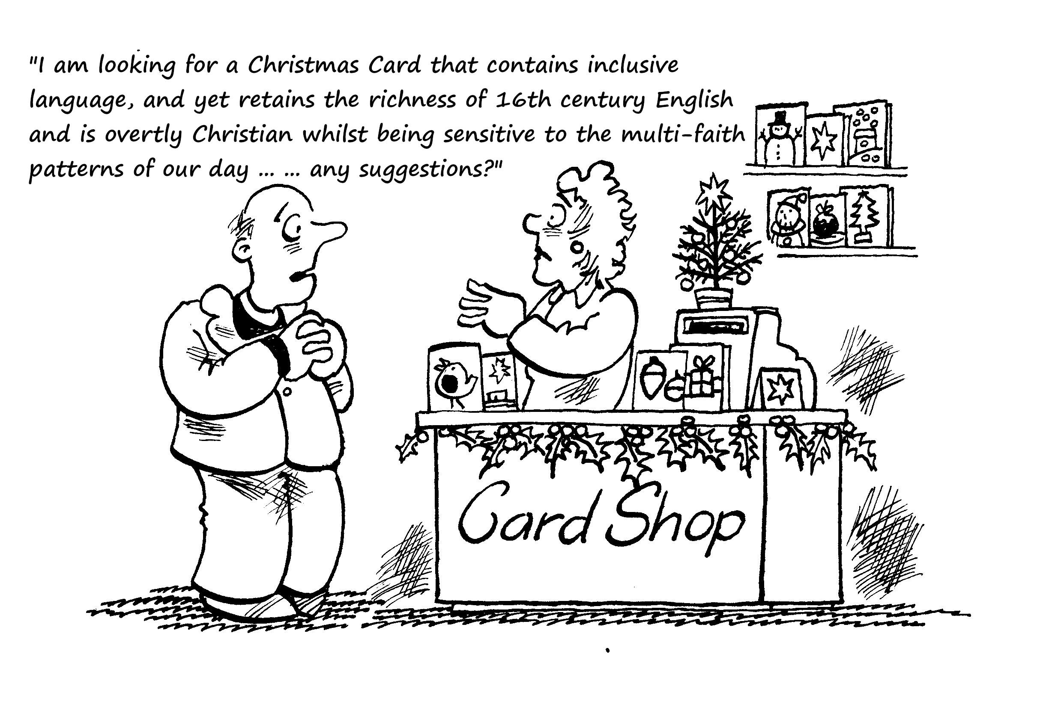

CHRISTMAS AND THE CHRISTIANS
For nearly four weeks leading up to Christmas Christians recognise a period called Advent. It means ‘coming’. It is a time of spiritual preparation. ‘Coming’ refers to Jesus’ first coming as a baby, but it also looks forward to a day when Jesus is expected to return in triumph at his ‘second coming’ to establish perfect justice and a new order of peace.
Originally Christians marked Advent as a time when they refrained from excessive eating and drinking. Then Christmas Day reintroduced them to the joys of feasting. Christmas celebrations lasted for twelve days, with gifts exchanged as a climax at Epiphany (6 January). Today, however, Advent is more likely to be associated with accelerating festivity, with the days following Christmas something of an anti-climax until ‘twelfth night’, on which decorations are removed. Many Christians worldwide are trying to revive the spirit of Advent by setting aside time to pray and address global poverty.
Christmas Day is celebrated as the anniversary of Jesus’ birth, although the actual date is not known. Most Christians celebrate it on 25th December. However, the Orthodox Church (the ancient churches in Eastern Europe and parts of Asia) follows a different calendar and celebrates on 7th January. Christians make a point of taking communion on Christmas Day. Many make it the first thing they do as the clock strikes midnight.
On 6th January the Christmas festival continues with a celebration of Epiphany, which means ‘the appearance’. Christians remember the visit of wise men (magi) to Jesus, bringing gifts of gold, frankincense and myrrh. The Christmas tradition of exchanging gifts originally honoured these men, who were the first non-Jews (Gentiles) to worship Jesus. It forms a reminder that in Jesus God was giving Himself for the benefit of the entire world. Orthodox Christians use this day to recall the baptism of Jesus as a grown man. The significance of Jesus being baptised was that He identified Himself with human beings in all their need. They mark the day by praying for God’s blessing on rivers, wells and water sources.
Christmas has never been just an escapist festival for Christians. Those who treat it seriously recognise that not all the world is able to face the days with frivolity or joy. The day after Christmas, Boxing Day, was historically marked as the feast of St Stephen. He was the first man to be put to death rather than give up his belief that Jesus was God. And two days later a day remembering the Massacre of the Innocents recalls Herod’s attempt to destroy Jesus by killing all male babies in Bethlehem. Although not so widely marked as Christmas Day, it gives Christians the opportunity to pray for children in today’s world who suffer as a result of the actions of adults.
Tom Tugendhat MP Christmas Card Competition
Every year Tom Tugendhat, our Conservative MP invites primary school pupils from within his constituency to take part in his Christmas card competition, with the winners being printed and sent out as his official Christmas card. Pupils are asked to design a Christmas card on A4 (portrait or landscape) using any medium with the winning four designs each receiving 100 copies of their own card, a tour of the Houses of Parliament with their parents and a special prize! This year Sienna Omurca, one of our junior church members, is one of the winners!

An extract from the small ads in the Courier in 1931 with a vague link to Christmas
“Edenbridge – Delightful residence. Just off the main road; 3 reception, 5 beds, bath, gas, water, tennis, 2 garages, 10 acres; to be let £125 per annum. Possession at Christmas.
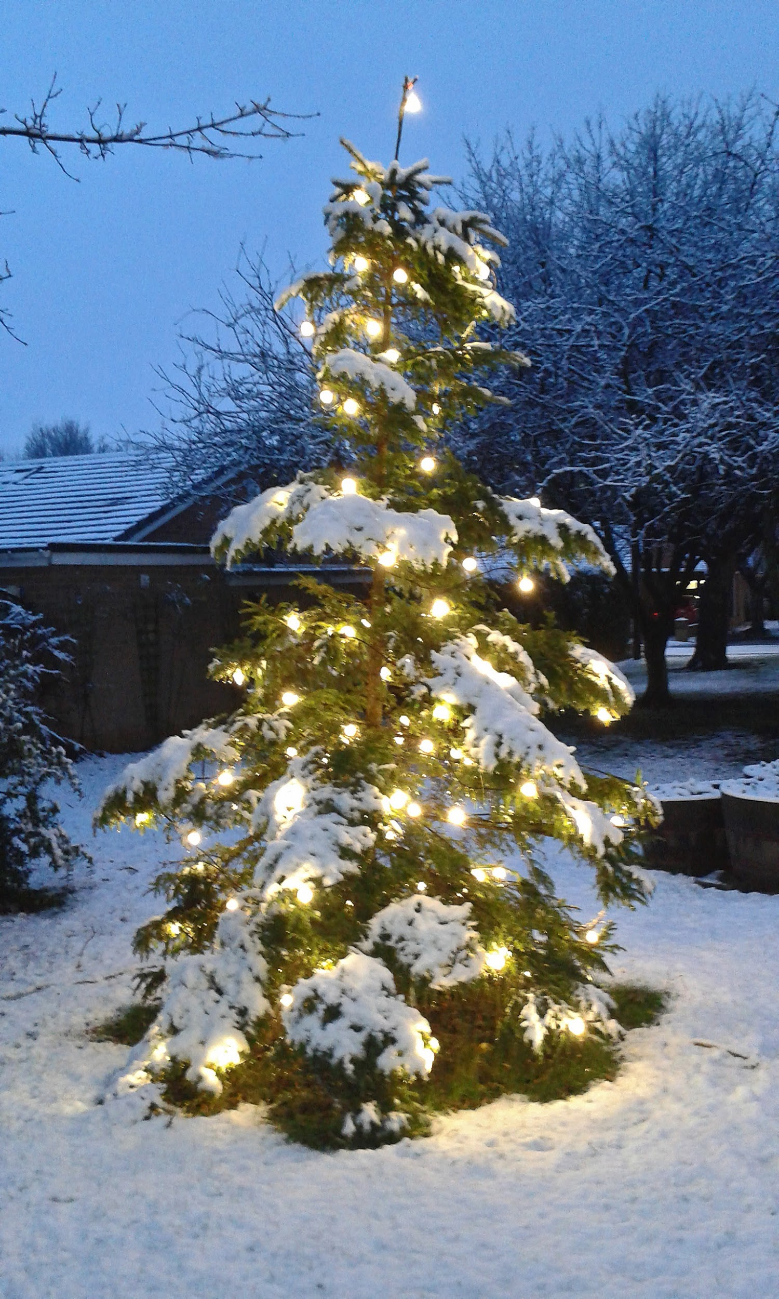

Did you know that mince pies have been traditional English Christmas fare since the Middle Ages, when meat was a key ingredient? The addition of spices, suet and alcohol to meat came about because it was an alternative to salting and smoking in order to preserve the food. Mince pies used to be a different shape – cradle-shaped with a pastry baby Jesus on top (see end of newsletter!)
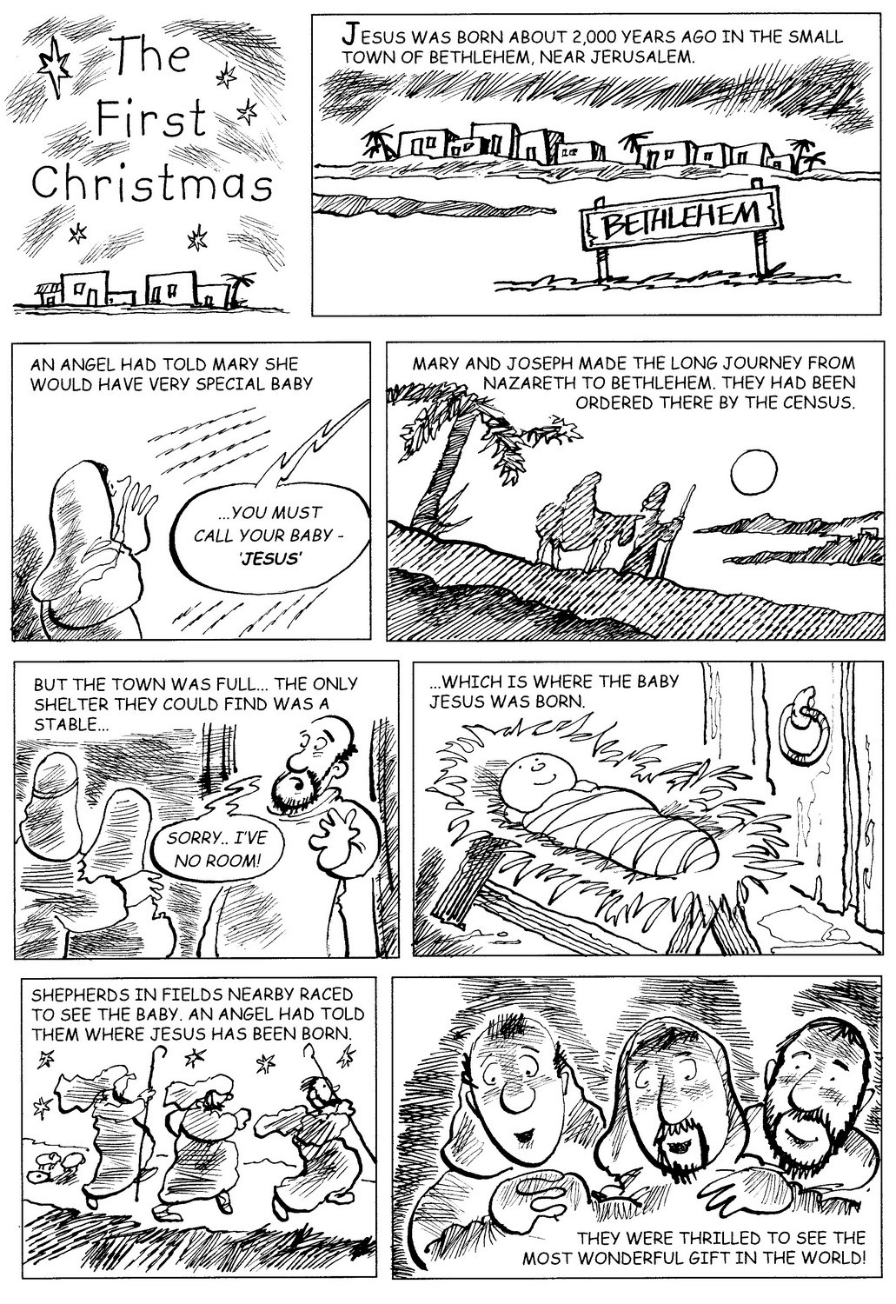CHRISTMAS LETTER FROM THE MODERATOR

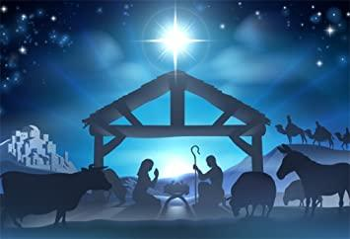
Christmas 2020

Dear friends,

As I write the papers are saying ‘Christmas is cancelled this year’. What a dreadful thought! And now the recent lockdown makes us worry who can be in our bubble or whether we are going to spend Christmas alone.

Of course, the real Christmas is never cancelled and that is a great relief for the whole world. Like many ministers I am at home this year, shut in my study answering emails, doing Zoom meetings and making phone calls. It’s a very different type of ministry we are engaged in. We need to remember Christ’s coming more this year maybe than at any other time.

Friends have said they cannot wait to put up decorations: the sparkle and ribbons, the lights piercing the darkness of a December afternoon, the hope of presents and a great big tree all lit up. In truth, this year we really need Jesus. We need the Lord to give us hope where we have lost it.

It always seems amazing to me that God should choose a helpless baby to pierce the darkness of the Roman empire and the hardness of humanity’s hearts. But God did. A baby who has come for over 2,019 years and will come to us again this year – despite a pandemic. We may choose the tinsel and sparkle of Christmas, but Christ chooses our hearts.

⁸ And there were shepherds living out in the fields nearby, keeping watch over their flocks at night. ⁹ An angel of the Lord appeared to them, and the glory of the Lord shone around them, and they were terrified. ¹⁰ But the angel said to them, “Do not be afraid. I bring you good news that will cause great joy for all the people. ¹¹ Today in the town of David a Saviour has been born to you; he is the Messiah, the Lord. ¹² This will be a sign to you: You will find a baby wrapped in cloths and lying in a manger.”
Luke 2:8-12

As we approach Advent and Christmas, we know that this year we are living in challenging times. We may not be able to sing of love coming down at Christmas in our churches, we may not be able to be with family and friends and the brokenness of the world continues. Yet Jesus, the Christ- child, the Light of the world, will still come to us. Christ is still the source of our hope and joy. Nothing can stop our Lord coming to meet us where we are.

“Do not be afraid. I bring you good news that will cause great joy for all the people. Luke 2:10

Christ is a never-ending source of love, light and wellbeing. Not only are we the cracked clay pots in which Jesus places the light of the world, we are the vessels God uses to spill out the light of love into the world. Full of this light we know we don’t have to be afraid of the future. For God is with us. With us in pandemics, injustice, bereavement, pain and fear. Christ is never cancelled from our lives. All we have to do is shine.

I wish you and your families, a very blessed Christmas.

ECO-GROUP REPORT

In spite of the difficult circumstances this year,the eco group has still managed to meet and to continue to uphold the environmental ethos of the church.
Gill managed to persuade Waitrose to make us one of their local charities from which we received a generous £330 which will be put to good use in the future when we hope to create a pond in the nature garden to attract more diversity of wildlife.
We also had an interesting meeting there with a lovely lady called Sarah Gough on 14th September. She is an Eco church volunteer who was keen to see what we were doing but also gave us lots of ideas and links including a pond specialist who may be able to help us with that project.
A HUGE thank you to the George family who kindly cut the grass for us (well I think it was Chris with a little help from his friends!). This was a really wonderful job.
Another thank you as always to Anne for organising the sheep visitors from Polly , who are such a great asset in so many ways. Also thank you to Anne for checking on the bindweed and persuading David to help with its removal and for keeping a constant eye on progress.
Two more benches have arrived,one kindly donated by Judith in remembrance of Albert who,I'm sure would have appreciated sitting on it on a fine day.
We have continued,individually, to sign petitions working towards a greener world and Gill and I took a socially distanced harvest festival service with those sort of issues in mind.
Sadly, with Covid at the forefront of every governments' minds, green issues have been taking a back seat , but we can only pray that this situation will be rectified next year and in years to come.Please continue your own good work and persuade others to do the same.
Liz Crothall

A LETTER FROM BARBARA PROWSE
in memory of Tom Thompson
“I thought you might like to put this poem by Tom Thompson in the Newsletter. There may be people in the congregation who will remember Tom. He used to submit poems to the Edenbridge Chronicle some years ago. He was also a fine artist and involved with lots of local issues in the town.
Sadly, he died on 17 November, but celebrated his 100th birthday in a care home, near one of his sons in Gillingham, in February 2020.
I was looking at his book of poetry which he gave to my husband and I in 1997, and thought it would be suitable”:

ONCE A YEAR
“Away in a manger”, the children sang,
Their voices uncertain and small
Proud mothers’ eyes, like bright butterflies
Fluttered and glanced round the hall.

“We three kings”, and “Wenceslas”,
The fathers joined in as one voice.
Together we sang, and the rafters rang,
“Good Christian men rejoice”.

We sang them all in that little church hall,
The carols both new and the old.
Then we gathered our coats, our hats and gloves
And moved through the door to the cold.

The vicar stood there with his blessing and prayer
As he wished us, “Goodnight and good cheer”,
Then as we moved off, I heard his last words,
“Look after them Lord, ‘till next year”.

FROM OUR PARTNER CHURCH, OXTED URC

OXTED Adventure Christmas Tree Trail 2020
An opportunity to get into the ‘Christmas spirit’ and to do some exercise!
Starting in early December in the grounds of St Mary’s Church, Oxted, an additional tree will be decorated each day in the run up to Christmas with a ‘Round the World Theme’.
Look out for the Oxted URC tree to be decorated on the 8th of December with ‘Denmark’ as its focus! Members of the Eco group will decorate the tree reusing decorations and recycling where possible.
You can visit the trail at any time but for safety reasons, please follow the one-way signs and follow government regulations.

BLACKBERRYING - SIMPLE AFTERNOON PASTIME OR A SEASONAL WAR?

For the past 7 or 8 years, in later summer/start of autumn, Mum and me (and occasionally other friends) have always gone blackberrying. The Season varies according to the weather - usually mid July-mid September. I say season, but maybe I should say campaign, because it feels like it's more like planning a battle campaign/war. There's all the stages of a military campaign/spying out the enemy terrority, identifying which places might be best to raid this year, seeing how heavily defended the blackberries are by the bramble. It really does feel like after all this time that Mum and I are veterans. There's the glee of identifying a nice rich patch or disappointment because as the old saying goes "no battle plan survives contact with the enemy" - which includes possible setbacks, such as one patch that was promising last year and you'd earmarked it as a favoured patch not being so productive or even because you've just missed the best of patch that seemed to be rich in pickings one week and now is barren the next.
There's the joy and satisfaction of seeing a box filled to the brim with nice fat plump fruit, or even the guilty pleasure of the sweet, distinctive but just slightly tart taste of a berry just slightly squished or at the end of the day - eating a few because you've filled all your containers.
But then there's the hazards, the annoyances of seeing really ripe blackberries that are just way too high or just too well protected by the thorny defences of the brambles, getting pricked by all the prickles, of wading to far into the brambles and being ensnared and caught - the minute war wounds of scratched arms, fingers and thumbs, of getting stained with either blackberry juice or occasionally in really nasty cases your own blood. Forget Day of the Triffids - I reckon if blackberry brambles were a sentient carnivorous plant we could really be in trouble. The agony of reaching for a plump fruit only to see it totally squished or drop into the grass or the hedgerow, never to be found again. There's even a bit of an arms race, blackberries growing thicker thornier stems to be encountered by human ingenuity and weapons such as secateurs or gadgets that can grasp and pull apart thorny defenses of seeing if you can arm yourselves with protective gloves or sweater, of teamwork - working out who's best to reach which blackberries (I do the high branches, being almost 6 and a half feet tall mum does the lower ones or organises the containers) or combining forces to pull apart spiky, spiny defences. And then the satisfaction of seeing how much you've got after a trip - and at the end of season, we've even had the satisfaction of know that our harvest will last till the next season
Mind you I suppose if Blackberries could talk, we might get a different tale - of these strange foes who pounce on them like the Vikings of old, beating them back, ripping apart their branches. snapping and then plundering their means of surviving and reproducing - I mean it seems logical - with some fruits you talk about seed dispersal- and maybe that's still the cases for birds were their might be some mutual benefit - but there has to be a reason that they would grow such impressive and in some case impregnable defences. Well writing this is making me hungry - there's a patch of brambles right outside my flat that I've known about and there's lots of plump, ripe fruits. Time for a quick raid for the end of my late lunch - and then Mum and I plan to come back later in the week for more determined prolonged session at the end of another campaign in the Blackberry Wars.
Nick Gibbons

REMEMBERING CHRISTMAS PAST

I was a small boy growing up in the 1950s and I have a binary memory of Christmas Days past. Everything was clear cut in those far off days and alternate years were either wonderful or extremely dull. Let me explain.
Like many families still do, we took it in turns between spending Christmas at home or away. Away meant an exciting train journey from Euston to Liverpool (with a steam engine in charge, of course) where we were met by my uncle in his shiny car. A ride in a car was a novelty for me. And then more excitement as we set off for the Wirral through the Mersey Tunnel.
I am an only child and I was spoiled rotten when staying with my aunt and uncle. There was lots of lovely food and my cousin, who was much older than me, looked after me rather like she would a large doll! They lived in a large comfortable house and I remember that there were presents not only on Christmas Day but for every day that we were there. So you can see why Christmas was wonderful – at least in my eyes.
Christmas Day at home was my parents and I, my grandparents who lived locally and two maiden great-aunts who came on the day by 159 bus all the way from Hampstead to Norbury (and back again). Auntie Lily and Auntie Emily seemed very old (they were probably my age now!) and belonged to the generation who never married because of the shortage of men after World War 1. There wasn’t a lot of fun for a small boy, although I do still remember one year when Auntie Lily enjoyed one ginger wine too many – she didn’t drink and confused ginger wine and ginger ale!
It all seems so long ago but at least we were able to meet without restrictions. The contrast between last Christmas when we had a houseful for several days and this year when we won’t be seeing any children or grandchildren inside will in some ways be like my childhood experience of being home alone (well almost), but it can still be wonderful rather than dull.
Mike Musgrove

KNOW YOUR MODERATOR

Dear friends,

I have been asked to share a bit about myself, so here goes:

I was born in Cuckfield, West Sussex. We were living close to my grandparents who lived in Hassocks. They went to Hassocks Congregational Church while my parents went to a little Anglican church in our village. Apart from 2 years in America, I have spent most of my life in Oxfordshire or Sussex, though I have moved about 17 times in total.

It was my grandma who told me the stories of Jesus. I usually sat on her knee and she read from her bible. When I was old enough, she bought me a Good News bible which I started to read but I don’t remember how far I got with it. However the stories and love from the bible must have stuck because I committed my life to the Lord as an adult on July 12th 1987 in a Baptist Church evening service and I have never looked back.

I left home at 19 to start my nursing course at Southampton University which I really enjoyed. I then went to do Midwifery at Oxford. I worked as a Midwife for about 10 years before going into research. I worked on several Department of Health contracts finishing back at Oxford University. All the time attending church, ending up at Temple Cowley URC in Oxford.

When I received my call to ministry and began my training I worked for a Community Development company. I used to think what an odd group of skills I have grown but being a minister in a church ready for regeneration, it all came in handy.

I love the URC. I chose to join the church because of the Statement of the Nature, Faith and Order. It made a great impression on me. Here was a church that was willing to stand up for its principles and also try and change. I knew that it was going to take time but change was written into its heart!

I am looking forward to visiting the churches when we are allowed to again. We are all learning new ways of being but we are empowered by the Holy Spirit and have many gifted people.

Thank you for all you are doing in your local church.

God bless

Bridget

