ST JOHN’S URC CHURCH MARSH GREEN

HARVEST 2021 NEWSLETTER

INTRODUCTION

As you can see above, this edition of the Newsletter looks a little different. This is an important month for the church in Marsh Green. As Graham’s letter below reminds us, he is retiring as our Minister. Presentations were made to Graham and Moira at his last service in Marsh Green on 19 September, and are being made at a joint final service in Oxted on 26 September. We thank Graham and Moira warmly and wish them well in the future.

Our Harvest Festival service marks what may be a longer than usual period without a dedicated Minister to lead us. So all of us in the church have to step up and make sure Marsh Green church is a lively and welcoming place which attracts people to support its mission even without a Minister. The harvest festival has always been a highlight of the year for our young people, and in this edition, and at this year’s Harvest Service, we recognise their contribution through the Festival drawing competition. Art by the children who have stepped up to enter is displayed in this newsletter. Do look at these. They are first rate. They will be displayed in the church, and prizes presented, at the Harvest Service on Sunday 3 October at 10.30.

I am grateful to so many members of the conjugation for stepping up with their contributions this month. I do hope you make it to the endpiece with Gary’s fascinating memoir of Marlpit Hill in the 1950s.

MINISTER’S LETTER

Dear Friends,
This will be the last time that I write to you via the newsletter and it goes without saying that it saddens me. I had hoped to have stayed with you for a further period but that was not to be.
As I write I have been looking at the news and although we seem to be emerging from the lengthy lockdown things are still far from normal. Thousands are still being struck down by Covid and indeed many are still in hospital and dying. We must give thanks that we in our community have been relatively sheltered.
Abroad we see international events escalating with the events in Afghanistan very much in our minds. We are reminded that we cannot rely on the promises of politicians to save our world. Then too on a natural level we see the volcano in the Canaries, the earthquake in Haiti and the destruction caused by fire in Australia. When we think of all this it is sometimes easy to think that we are a rudderless ship in a storm at sea. But as the disciples were to learn when Jesus is on board in our lives we are never out of control however much it seems so.
To me the last few months have not been easy and a bout of ill-health has not helped. I would like to thank all who sent good wishes and cards via Moira, it is much appreciated.
But now we must all look forward; we are free of many of the restrictions that had been imposed on us and we must work towards opening the church to all so that none are apprehensive of attending. We have seen the church opening up and we have had a very successful afternoon tea; we were blessed with great weather and many visitors. We must continue to work on our mission outside of the church, many have suffered much more keenly than we have. Then the church is having to anticipate a considerable time without a minister. I have every faith that given the resilience of church in Marsh Green that you will cope and I pray for God’s help for you in this.
Moira and I are also entering a new phase in our lives. I will not be retiring but will continue to work with the church in the Wessex area on a voluntary basis and of course Moira has a very busy schedule in addition to the publishing of her book and who knows where that will lead.
So it remains for me to wish you all every good wish for the future.
With much love in Christ
Graham
Revd Graham Dadd graham_dadd@yahoo.co.uk
“Perhaps he’s heard that we’re losing our Minister!”

DIARY FOR AUTUMN 2021 - CHURCH SERVICES

WORSHIP LEADERS FOR SERVICES IN OCTOBER AND NOVEMBER

OCT 3rd Harvest all-age service led by Gill Musgrove and Liz Crothall
Followed by Harvest Auction in aid of Christian Aid.
10th Revd David Skitt (Service includes all-age Communion)
17th Barbara Mitchell from Ss. Peter & Paul Edenbridge
24th Shirley Homan
31st Mark Rigby from Tonbridge URC

NOV 7th ‘Caring for each other’ led by Jean Gibbons and others
14th Stuart Dew
21st Hilary Morgan
28th Revd Steven Mitchell from Ss. Peter & Paul Edenbridge
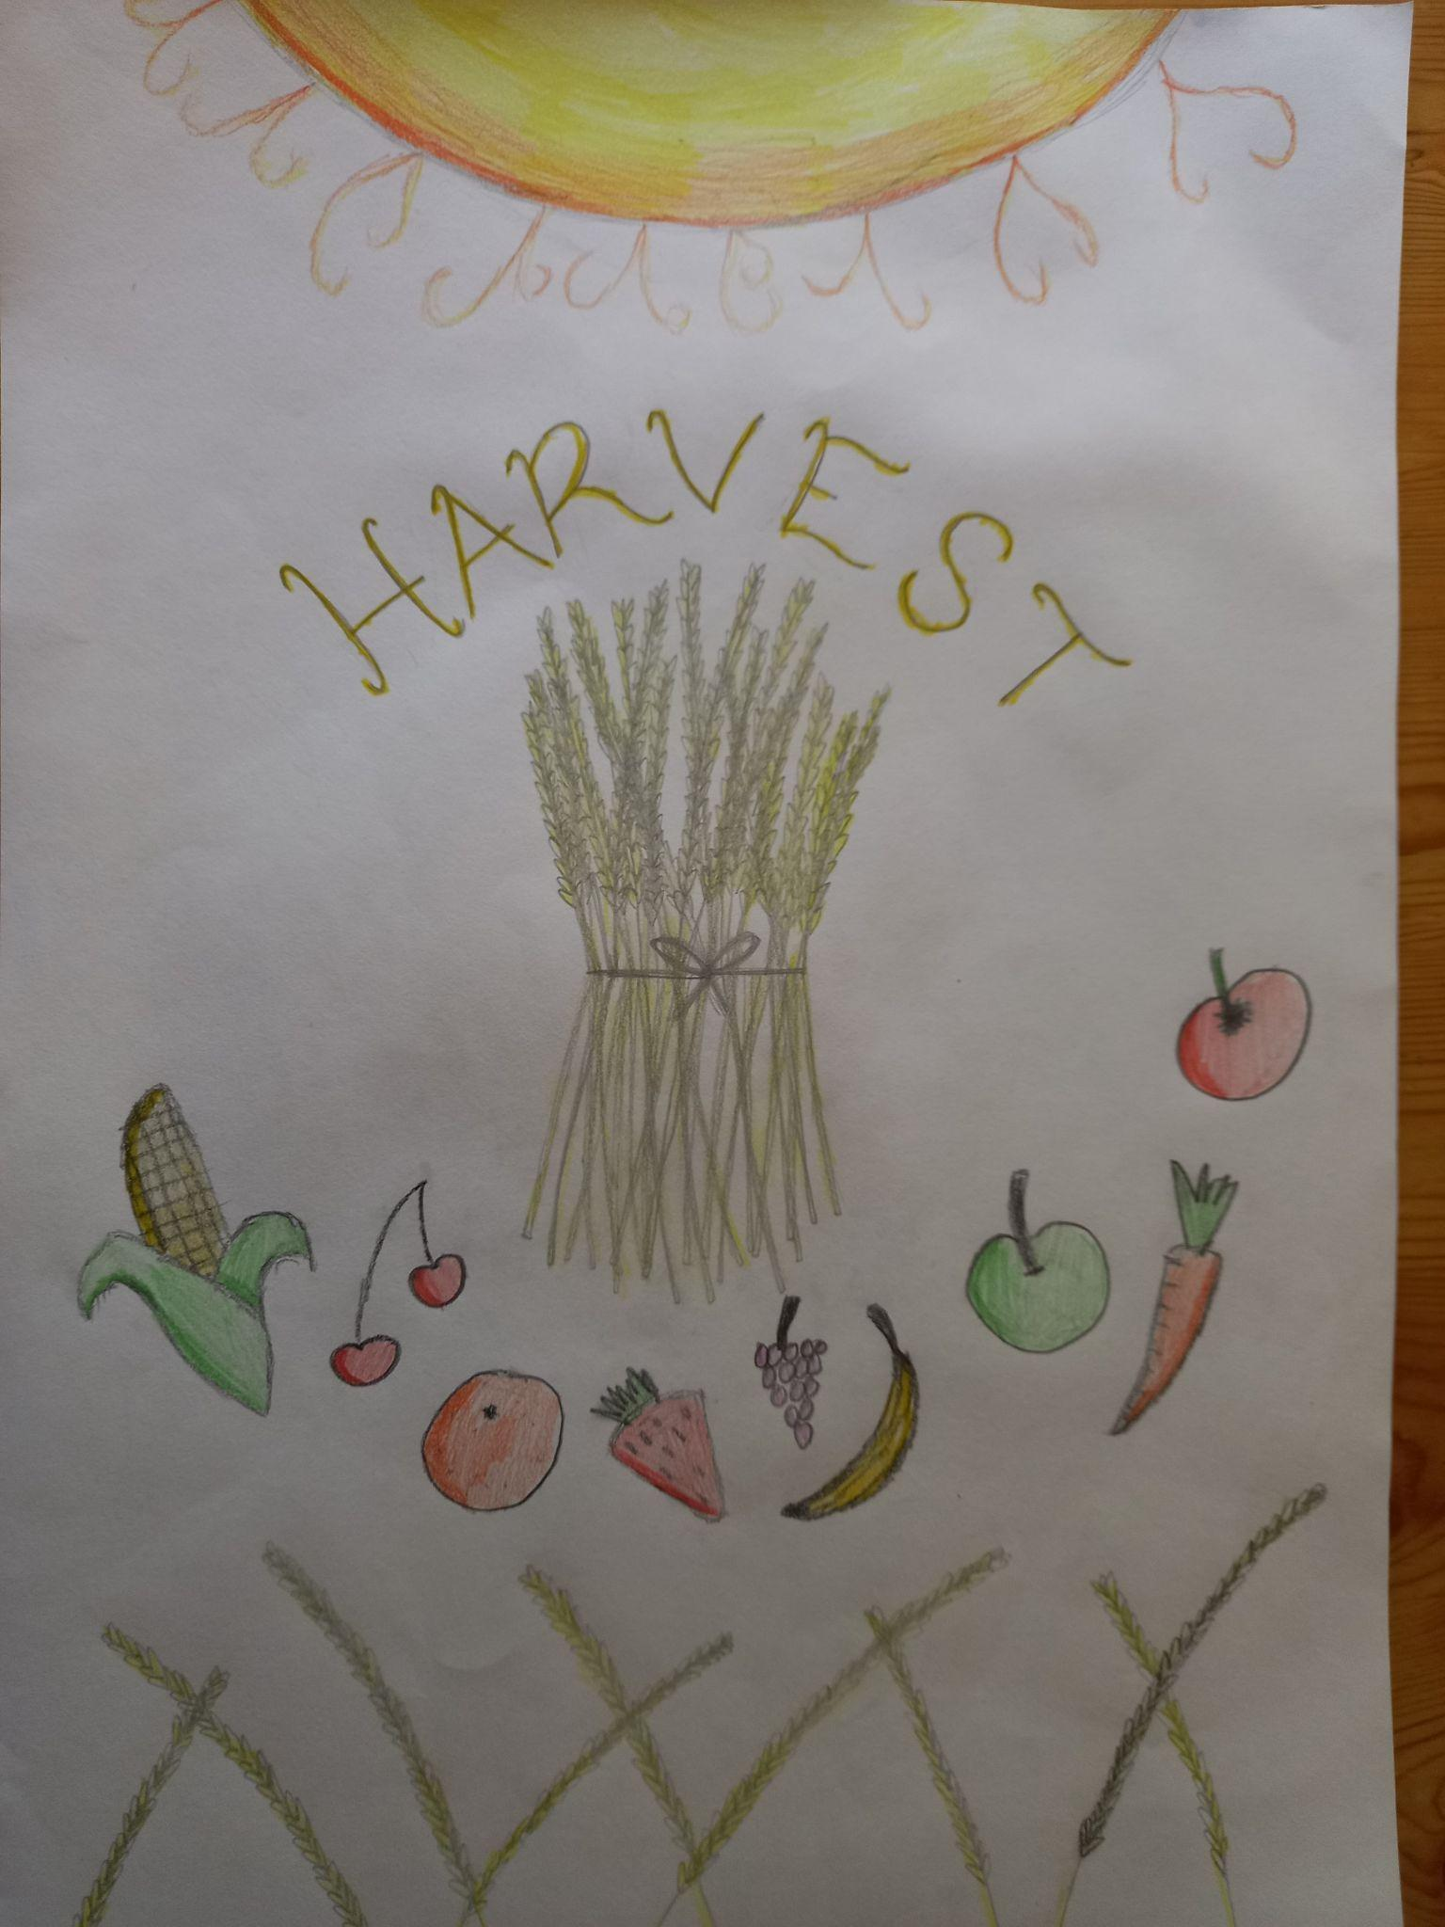

EVENTS

OCT 2nd 8.00 pm Eric and the Claptones Charity Gig for Cancer Research and Macmillan Trust
Summer Teas
Sadly we were only able to have two summer teas this year but we had good weather for both and they were well attended by visitors from local churches and others in the North Downs Cluster. The sign on the church was also noticed by two passers by who enjoyed the tea and the music so much that they stayed the entire time.
This year, in addition to the delicious cakes, the plated scones with individual pots of jam and cream were a great success, as was the personal service to the tables, with a young waitress making sure everyone had what they wanted. On both occasions the relaxed atmosphere was enhanced by music - David and Sara, with guitar and violin on the first occasion and Bernard on fiddle and melodeon on the second. Our visitors very much appreciated these relaxed social occasions and some are already asking when they will take place next year.
Those at the most recent tea were also able to appreciate the pre-school’s new sensory garden at the rear of the church. It is there now for you to enjoy after services or at church events: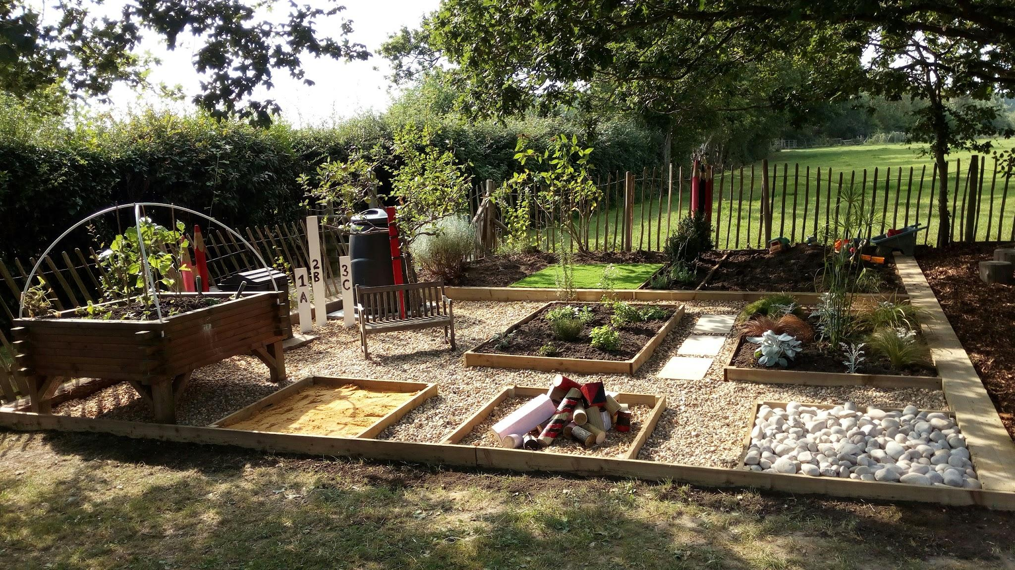

Church Secretary Elizabeth Richmond
richmondshire@btinternet.com
Tel: 01732 863368
^{A call for flowery donations}
Every week we not only enjoy flowers at the front of the church but the flowers are then given to someone and this is a rather lovely little outreach element of our Sunday that some people may not be aware of. We are in need of some new volunteers for our flower rota. It involves buying or picking the flowers and displaying them in church before the service. Each person on the rota does this once or twice a year, sometimes more if they are happy to. If you would like to be part of this simple and beautiful offering please let me know.
We also need volunteers to clean the church – not such a lovely task but equally important. And usually very, very satisfying and much appreciated. I have this rota too if you could speak to me about how you could help in this way. Please step up. Thank you.
^{Heidi Tanner}

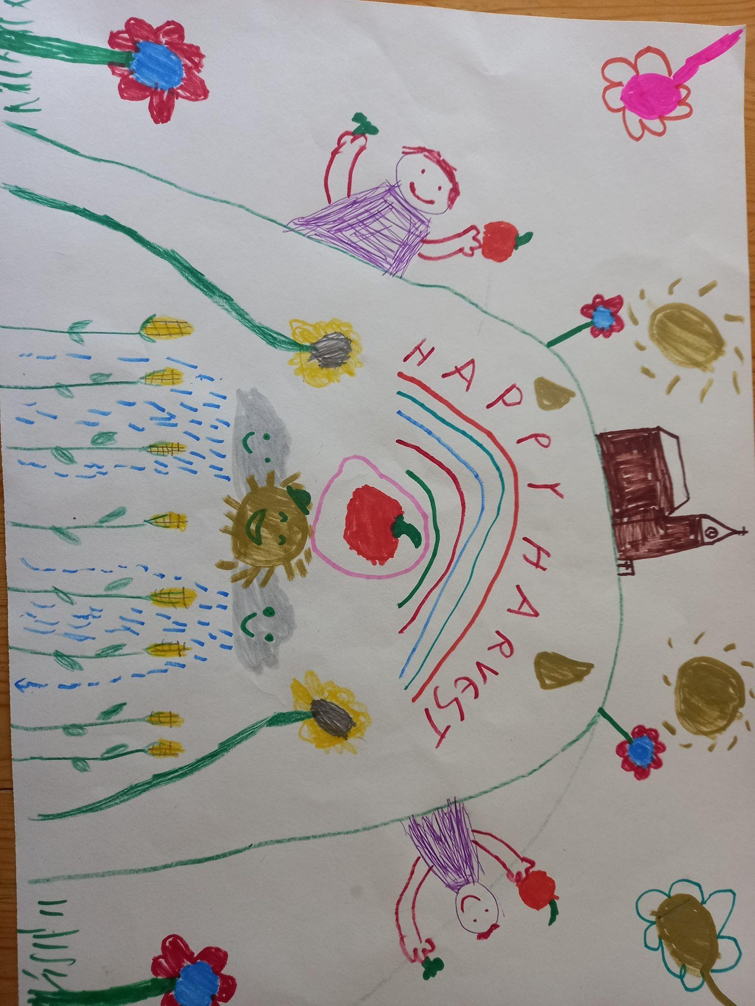

AND A CALL FOR HELP WITH TECHNOLOGY…..

Technology is playing an increasingly important part in our worship and to spread the knowledge (and workload) we are hoping to put together a rota of people to help with the Digital Hymnal, preparing the weekly Powerpoint presentation and projecting it and also recording services.
There are a number of different roles:
- Programming the Digital Hymnal (this is done during the latter part of the week before the service). The new Hymnal that we use now is much easier to programme.
- Operating the Hymnal during the service on a Sunday, either when it needs setting up or has already been set up.
- Preparing the Powerpoint presentation. This normally involves copying hymns from a ‘library’ of hymns that we have projected previously. We have been projecting hymns for several years so there are about 300 in the ‘library’ already. Occasionally a hymn will need to be input from scratch. From time to time the person taking the service will also want to project an illustration which will need to be included.
- Projecting the presentation when the system has already been set up on a Sunday morning.
- Projecting the presentation when it has already been prepared but the system has not been set up.
- Recording the service (at present this has to be on your own equipment, i.e. a phone with a good amount of memory).
A reasonable knowledge of Powerpoint is needed for preparing the presentation but all the other roles are pretty straightforward and training will obviously be given.
I hope that a number of people will be willing to volunteer for any or all of these roles as it is really important that we have cover in times of holiday or illness. Please see me at church or give me a ring on 865138 if you are interested in stepping up.

Mike Musgrove

POEM by Shirley Homan

I wrote a poem while I was on holiday last year during the first lockdown. I have never written poetry before.
This poem was about a walk we took up the road where we had rented in Twomakeady in County Mayo . We walked up the road and sometimes when we walk back the way we have come in life we see things differently!

“The Road Twice Travelled”

Sheep stare then continue on their business
Farmer moves the sheep from the field above
across the road
We chat - black headed mountain sheep in Mayo
Sheep dog curved round us both looking for acknowledgement
Rain shimmering on the stone walls drips languishingly down the Fuchsias
The hedgerow - red speckled green
Turn to walk back down the hill
Two men with walking sticks and caps
Lean against the gate now tied up to keep the heifers safe.
We chat about their friendly sheep dog whose coat is thick and surface wet.
He looks for a friendly stroke and allows us to break our stride and engage
The road twice walked

Shirley Homan
September 2020

A BYGONE HARVEST AND OTHER THINGS

Readers may be interested in this article from The Kent and East Sussex Courier for 5th October 1928
“On Sunday Greybury Presbyterian Church held its Harvest Festival. The services were well attended, the one in the evening being attended by friends from Edenbridge, Cowden and Dormans Land. Two anthems ‘O taste and see’ and ‘The earth is the Lords’ were rendered by the choir. A sale of gifts was held in the school on Monday, Mr H Tatnall acting as auctioneer. The amount received at the sale and collections, after suitable gifts had been put aside for Hospitals and sick people, was satisfactory. Thanks were expressed by the Rev. H. King to all friends who had worked so loyally and given so generously for the success of the cause.”

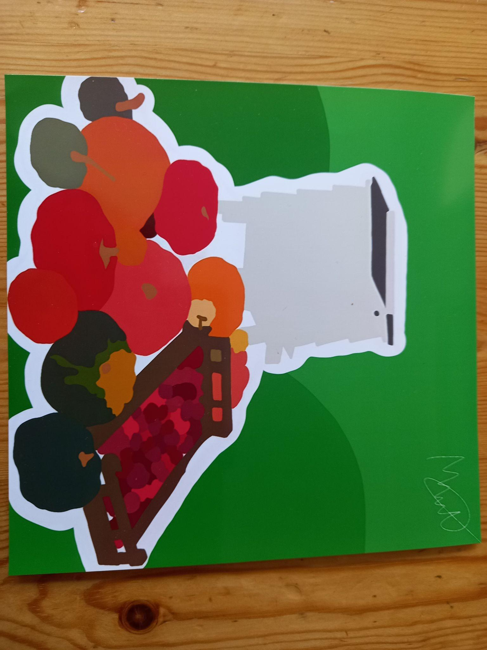

THE FIRST CHURCH IN MARSH GREEN
In June the church celebrated its 139th anniversary as it was opened in 1882 but, for many years I have been intrigued by hints that St. John’s (or Greybury Church as it used to be known) was not the first church in Marsh Green.
On the Ordnance Survey map for the area which was published in 1891 but based on surveys made in 1869-70 there is a “Chapel (Plymouth Brethren)” shown on the north corner of Greybury Lane and Marsh Green Road. The second piece of evidence is in the 1871 census where there is an entry for “Chapel Bethel” in what must be the same place.
Can anyone cast any light on this or have any memories of a building at the end of Greybury Lane? There is a piece of land there which might hold some clues.
Another little gem from The Courier. This time from the 1950s.
“To help in the nationwide appeal for two million new savers, Edenbridge savings workers have offered to open savings accounts for all babies born in the town and surrounding villages between 1st January and 31st March. If parents are willing the Savings Committee will open an account with 5/- (25p in today’s money) for all such children.
The first baby to benefit from the scheme in Edenbridge is David Sayell of Manor Farm, Marsh Green who was born on 30th January.”
You can ask David what year this was!
I remember that when I was at Primary School about this time there was a big push to get us all to buy Savings Stamps. These bore the head of Prince Charles or Princess Anne (depending on the value) and we used to put them in thin books which could then be exchanged for a National Savings Certificate.
Mike Musgrove
ECO-GROUP
IT’S ALL HAPPENING THIS AUTUMN!
Harvest is here. Those of you who grow your own vegetables (or even just your own weeds) at this time of year will understand the meaning of bountiful. If the garden is running away with you, don't worry too much. Prolific vegetables mean lots of low carbon and low food miles food, and prolific weeds means that your garden is good for bugs, bees and other wildlife. Both are good for climate and planet – and our poor planet needs all the help it can get.
Talking of the planet you are likely to be aware that there is a critically important international conference, COP26 in Glasgow in November. Please pray for progress and if you see a relevant petition, please sign it, and it would be wonderful if you would spare the time to write to your MP and ask him (or possibly her) to lobby the Government to do all it can to achieve meaningful and far-reaching change.
Coming back closer to home there are exciting preparations being made to create a wildlife pond in the Nature Reserve at church. This is one of the most effective ways to increase biodiversity and it also makes it more likely that we would be approved as a release site for rescue hedgehogs; standing water is the only thing currently missing in the reserve to make a suitable habitat for these much loved and endangered animals.
See you at the Harvest Festival on Sunday 3rd October where we will be celebrating God’s bounty with thankfulness and looking forward to the future with hope.
Gill Musgrove

A PLEA FOR BELL RINGERS
Have you ever thought of bell-ringing? You don’t have to be able to read music, as we ring by numbers! It’s great fun. The bells range in size, and the more people we have the more varied the music can be. We started again on 9 September, and welcome new members.
Leader: Lynne Dabrowska. Tel 01732 862844.

Barbara Prowse has written a poem to encourage you:
HAND BELL RINGING
On Thursday morning we ring the bells
Just one Gent and several Gels!
Sometimes we make a hash of it
But other times we’re quite a hit.
The pieces range from Mod to Classic
Although our faces are never tragic!
We always manage Handel’s work
He ‘lifts us up’ so we never shirk.
We celebrate our Birthday times
With food and drink and gleeful chimes.
Our only sin is noisy mirth
And excess food on our days of birth.
We meet at 11 (am) for just two hours,
At the Parish Church among the flowers
So just turn up, never mind the weather,
For booming brass and scorching leather!

ENDPIECE
Memories of Marlpit Hill
Several of our church congregation live in Marlpit Hill, but as they are all newcomers (ie have lived there less than 50 years) I thought a picture of life in the 1950s might be interesting.
There were 5 shops. Andersons was a family grocers, incorporating the post office and a butchers. There were 3 Mr Andersons: Eric was the brains, Fred ran the grocery business, Billy was the butcher. They operated several ‘rounds’ in the district and the nearby villages. Orpins was the other grocer on the corner of Hilders Lane, another family concern. It was later taken on by a Mr Hamilton-Smith whose catchphrase was, “There’s been a run out!”, when whatever you wanted was unavailable!
The newsagent was Mr Hayden, a grumpy elderly man. Next door to him was Mrs Osman’s wool shop, later to be the Highland Cafe. (With little through traffic, who were to be their customers?) On the corner of Swan Lane, Mr Sawyer’s shop did cycle repairs, sold batteries and topped up your accumulator(?).
Two pubs, The Swan and The Albion, and two churches. St Paulinus was a ‘tin tabernacle’ in Hillcrest Road, the Baptist Church in Hilders Lane. The building now known as St Paulinus Centre was ‘The Institute’, where jumble sales, children’s parties and all sorts of events were held. Between the two was, and still is, the Marlpit Hill Men’s Club.
A dairy on the corner of Hillcrest Road and three (yes, 3!) builders yards - Hardings, Humphreys and Southons. In Swan Lane, a garage run by Mr Sawyer, as well as a taxi service. When I first started school in Haxted Road, I went by taxi as the bus service had not yet begun. (Mr Sawyer was a busy man - he was also Superintendent of the Baptist Church, then known as the Mission Hall).Before most people had cars, it was ‘shop local!’ I know Marsh Green was also a busy little community in the past with shops, a school, a pub and 2 churches. What a different world!
Gary Bradford
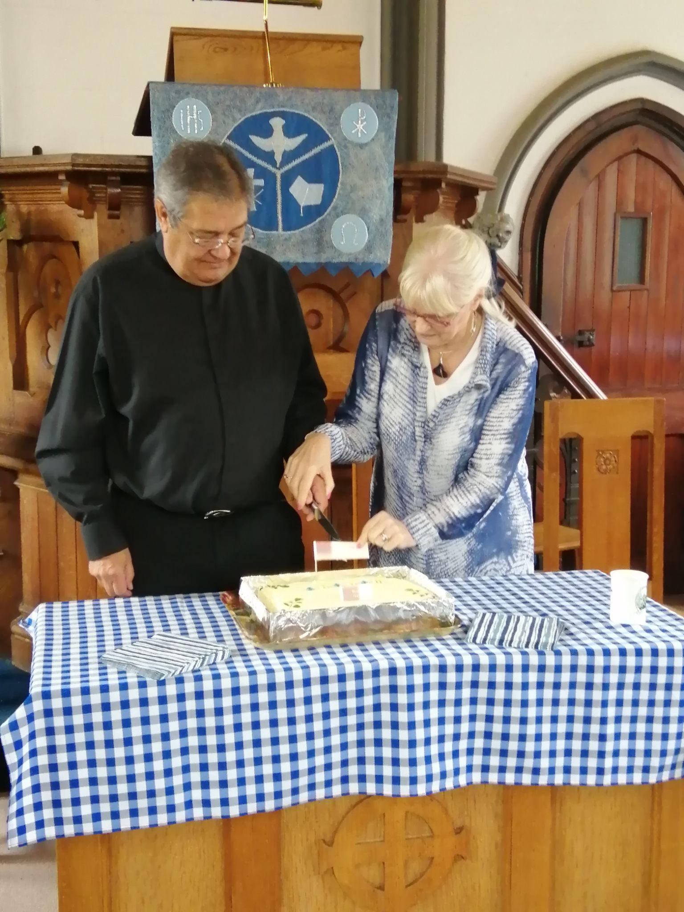
Graham and Moira cut the cake at Marsh Green after his last service.

AUTUMN PRAYER - poem by Muriel Martin, supplied by Barbara Prowse.