ST JOHN’S URC CHURCH MARSH GREEN

EASTER 2022 NEWSLETTER
INTRODUCTION

Welcome to the first Newsletter of 2022. For the church and congregation here in Marsh Green it has been a difficult couple of years, but we seem to be emerging from the restrictions of the pandemic even as the number of Covid cases reach a new peak. Despite not having had a Minister now for 6 months, and with no very rapid prospect of a new one, the church is full of activity, and at a local level we can look forward with some optimism. The same perhaps cannot be said of the wider world at the moment, where a perfect storm of difficulties is facing us all. In the absence of a Minister’s letter this month, I thought this short piece might give some food for thought:

HOW TO HAVE SOME HAPPINESS THIS APRIL

‘April is the cruellest month,’ wrote TS Eliot at the beginning of his magisterial poem, The Wasteland. And it is a good description of what April may bring us, between the war in Ukraine and soaring energy prices.

But apparently, major problems do not mean that we can’t enjoy anything. According to the ‘science of happiness,’ fuelled by advances in brain-scanning technology and a cultural shift towards seeing happiness as a key index in human development, there is a way through the deep gloom that hangs over this month.

Neuroscientists suggest that even while we are dealing with the big problems of life, we can also make room for ‘small, fleeting moments of fulfilment’. These can range from holding the hand of a loved one, to appreciating the daffodils in your garden, to enjoying a cup of tea with a good friend. Such moments of quiet contentment are ‘joyful vignettes’ which can be the bread and butter of our daily human happiness. As one writer has said: “Hold on to the small moments and the bigger picture of gloom doesn’t have to be as overwhelming as it first seems.”

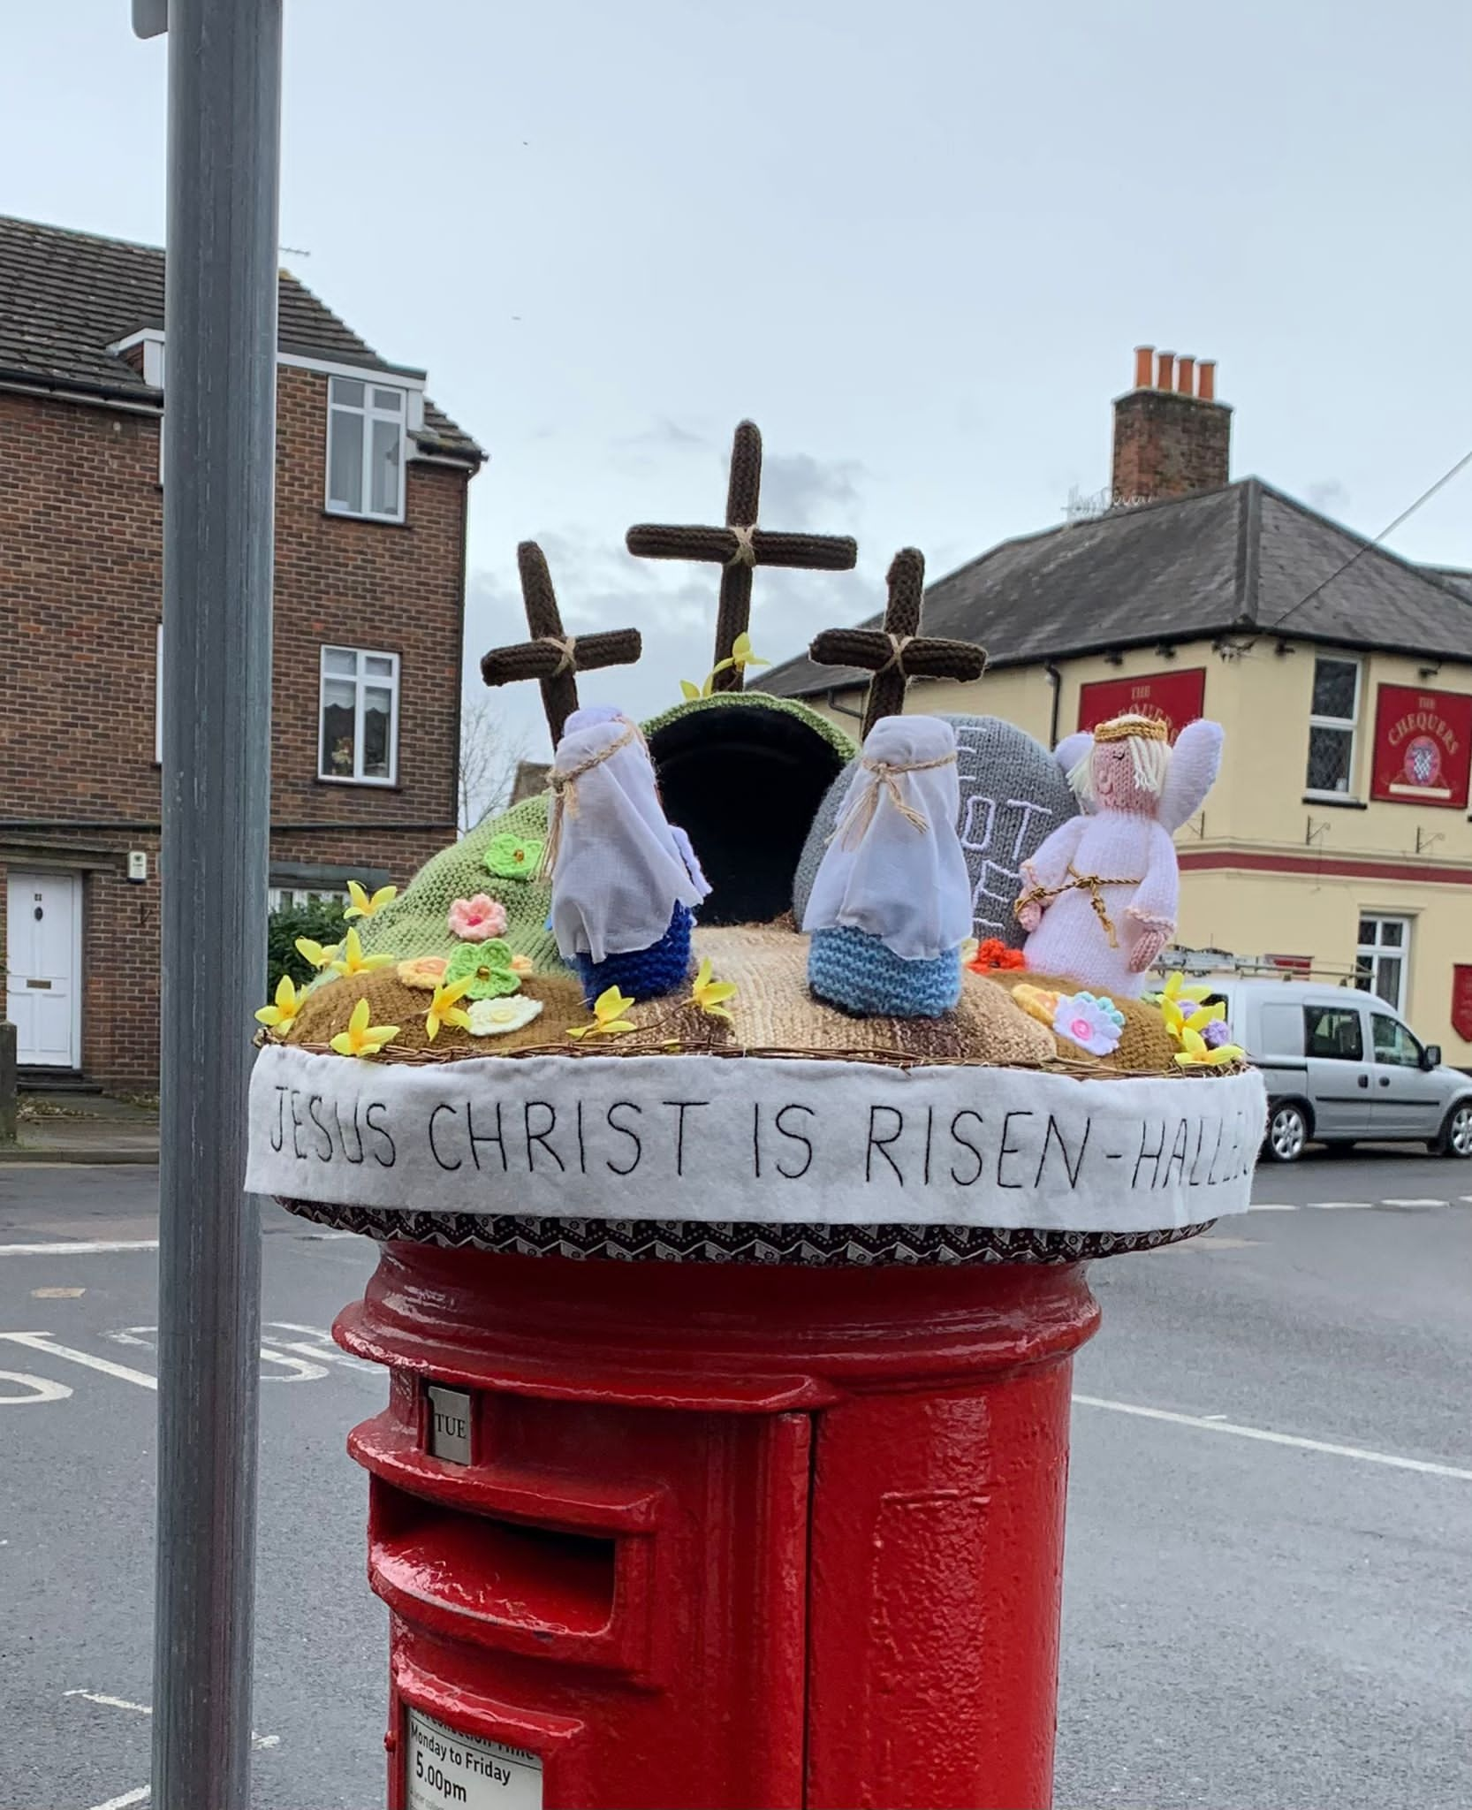
DIARY FOR EASTER
APRIL
14th 6.30 pm Maundy Thursday Communion
15th 9.45 am Good Friday Service led by Gary Bradford
10.30 am ECC Walk of Witness from the bridge
17th 10.30 am Easter Sunday Service with Communion
led by Revd Bruce Stuart, former minister of St. John’s, (followed by Easter Egg Hunt.)

SPRING/EARLY SUMMER CHURCH SERVICES
All services at 10.30 am.

APRIL
24th Bill Potter from Redhill URC
followed by Church Annual General Meeting
MAY
1st Tricia Rey
8th Christian Aid Service – Brad Frey and Jean Gibbons
15th Service with all-age Communion led by Gary Bradford
22nd Jon Dean from Sanderstead URC
29th Revd Graham Woolgar from the Eden Church
JUNE
5th Café Church led by Hilary and Peter Brand
12th Service with all-age Communion
Revd David Skitt, former minister of St. John’s
19th Gary Bradford
26th Church Anniversary
Revd Bridget Banks, Southern Synod Moderator
JULY
3rd Junior Church
10th Service with all-age Communion
Revd Martin Hazell, Moat URC, East Grinstead
17th Eco Service led by Gill Musgrove and Liz Crothall
24th Ian Fletcher from Horsham URC
31st Revd David Flagg

SUMMER TEAS – Saturdays 3.00 – 5.00 pm
These are planned for 18 June, 16 July, 20 August

ECO-GROUP

MOTHERING SUNDAY SUNFLOWERS

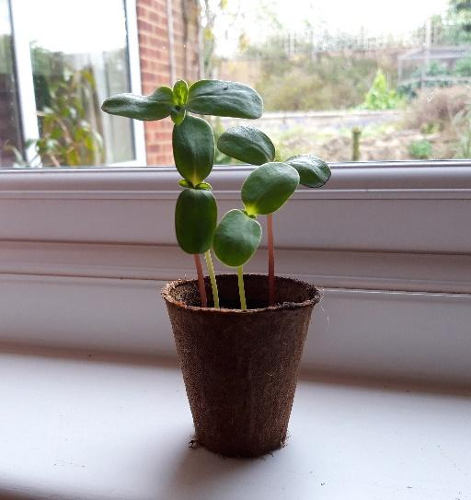
One of the Lenten Eco-challenges was to plant a new tree, shrub or other plant and to nurture it. You may or may not have done that on the designated day (it really doesn’t matter which days things are done any way) but on Mothering Sunday we were given another opportunity. I wonder how many of you who were there have successfully germinated four sunflower seeds. We have! They all took it in turns to poke their seed leaves into the big wide world. Strangely exciting. We can’t take much credit for it though since it was the church children who did the sowing; all we had to do was add water and remember not to stir. If you are one of those with sunflower seedlings do pot them up and do your best to keep them alive! In the summer you will have up to four beautiful sunflowers in your garden for the bees and then huge (well maybe) seed heads for the birds.

I wonder who will have the tallest and who the greatest sunflower seedhead diameter. We will have to compare notes – but of course it’s not a competition!

Gill Musgrove

TREASURER'S REPORT:
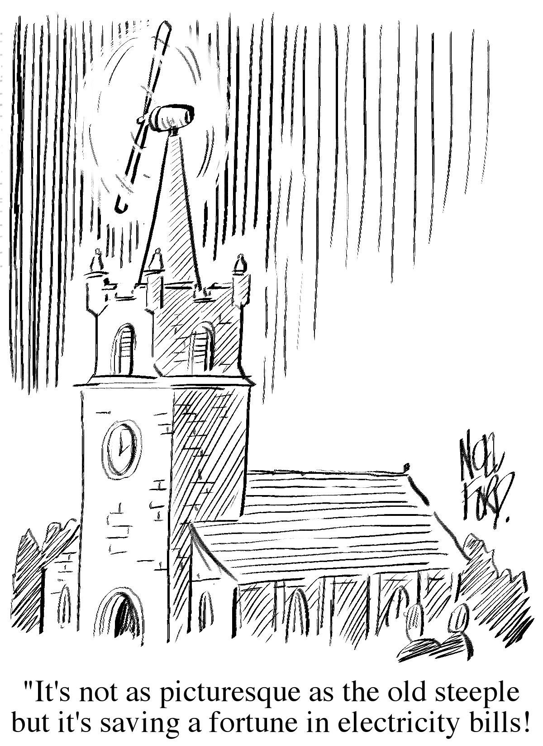

NEW BEGINNINGS
A group of about 10 or 11 of us have very much appreciated being part of a monthly discussion group led by Hilary Brand.
As we have been thinking about church, we have been asked to think about things such as:
The church as social group and the church as worship
What do we want from Sunday services?
What makes a church a church?
‘The church as a place to be accepted and a place to grow'
' The church as comfort and the church as risk - Jesus came to bring peace but also challenge, how can we appropriately offer both?'
We have been encouraged too, to take time between meetings to think more about ourselves and our understanding of God
- to be quiet and fully present to the world around us, to open our minds to the astonishing concept of God being fully present with us - how might accepting imperfection and being kinder to ourselves free us up to be kinder to others?
There has been much more, in a warm and supportive environment to share our thoughts.
We spent time too, on one of the evenings, to talk about the situation in Ukraine and how we might react positively to the distressing and hugely challenging situation there.
We have looked at Bible passages to help our conversations and we look forward to the final session on April 27th.

Jean Gibbons

Nature Reserve - Digging for Victory!

Summary of reports made in March by the churches in the North Downs Cluster

Before each meeting of the Cluster, each church sends a report on the period since the last meeting. Here is a much abridged version.

Many commented on how congregations were recovering after covid. Some have ‘hybrid’ congregations with the majority in church but others joining in through live streaming. Two are upgrading their A/V system. Two of the churches commented on the problems of an ageing congregation and the struggle to find new people so that the majority of roles are not undertaken by an overworked minority. Probably many churches will be in the same position.
Six of the churches are without a minister and by October the remaining three will also be in Transition. Appreciative comments were made about the range of interesting, informative and inspiring people leading their services.

Individual comments
Crawley Plans for a new community garden are progressing, with this initiative appealing to a wider group of people, who have volunteered to be on the team. This has brought new hope to the church in their mission.
Banstead has started a collection of used stamps for the Leprosy Mission.
Reigate Park is fortunate in having Sue Knight, the only Local Church Leader in the Cluster. They provide CDs of their streamed services for those unable to attend. They had requests from four people to become church members and were looking forward to three baptisms. They have received some grants towards employing a Children’s and Family Worker. In addition to collecting other objects that can be recycled, they are collecting blister packs.
Christ Church, Walton-on-the Hill is a very small church, sometimes joining activities with the Parish Church . A recent event was a very popular Pancake party which they hope will become an annual event. They are working to develop a community garden.
Caterham is working towards getting the Children and Youth Church Friendly Award. The church is a long standing supporter of the Croydon Centre’s work.
Redhill has been using the Upper Hall for services which can be heated in a fraction of the time with which they could heat the Church.
Moat, East Grinstead is sadly struggling at the moment with personnel but has a new Secretary.
Oxted It had been quite a busy but successful month at the church. They were grateful to their Lay Preacher, Matthew Griffiths for leading three services in the last six weeks. They continue to stream their services and will be installing upgraded equipment in April. They held a Big Brew and Traidcraft sale that was their first event of its type for nearly two years. All went smoothly and the event was a success both financially and socially. It was good to see YMCA Heads Together restarting face to face counselling sessions for youngsters.
There was a very generous response to their March Charity collection in aid of The International Red Cross Ukraine Appeal.
Marsh Green as usual contributed a report on events but you should know about them!

Elizabeth Richmond

ENDPIECE
JOHN THOMAS MORTON (1828-1897)
Whilst researching the early days of Greybury Church (now St. John’s United Reformed Church) I have acquired quite a lot of information about our founder and benefactor, John Thomas Morton or J.T. Morton as he is normally shown in documents and newspapers. I decided that it might be of interest if I tried to write everything down in one place to add to the church records, so here goes. This first instalment is about his life before he moved to Kent.
John Thomas Morton was born in 1828 in the Oxford Street area of London. His mother was definitely called Elizabeth and he is quite likely to be the John Thomas Morton who was baptised at Marylebone Parish Church in 1830 and recorded as being the son of John Morton, a baker, and Elizabeth. This family was living in Great Chesterfield Street, which is now Wheatley Street and located just north of Oxford Street.
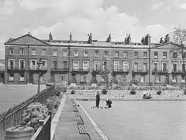
The next time I have found him in the official records is in the 1851 census where he is shown as living in Holford Square, near Kings Cross, with his widowed mother Elizabeth, his aunt Lucy Davis and a servant. He is described as an agent for preserved provisions. Holford Square was demolished in 1948 as it was unsafe due to bomb damage. As an aside Lenin lived there for a couple of years in the early 1900s.
So we can see that John Thomas had already started on his career in preserved food that he would continue for the rest of his life. In fact, it seems that this career started in Aberdeen in 1849 when he was just 21 as he had established a small factory there selling preserved foods to sailing ships.
He married Esther Sophia Chartier in 1857 in London and in 1861 they were living at Delaford Cottage in Theydon Bois in Essex (on the northern edge of Epping Forest) together with a son, another John Thomas, plus his mother and aunt who were with him in 1851 and two servants. The house today is valued at £800,000 so not bad for a 33 year old who was now styling himself as a Provisions Merchant.
I have no idea why he moved to Theydon Bois. The railway did not arrive until 1865 so it would not have been an easy journey to London. It is interesting that in a directory of Theydon Bois published in 1863 which lists the most prominent inhabitants, everyone is shown with first and last names and occupation apart from J T Morton who has no occupation.
As time went on JT opened larger and larger premises in Aberdeen and London. The Head Office of the company was at Leadenhall Street in the City of London with a sizeable processing plant in Millwall. The Aberdeen factory was in the area of the city called Rosemount.
Mike Musgrove (to be continued)
