ST JOHN’S URC CHURCH MARSH GREEN

EASTER 2023 NEWSLETTER

INTRODUCTION

As Easter approaches and the signs of spring rather reluctantly appear, it is a time of change in the church too. Stuart Dew, our interim Moderator, is stepping down and Ian Fletcher from Horsham, whom we know well, is taking up the new role of Visionary Companion. Ian will work with the Elders as we try to finalise the arrangements with the URC Synod as to when and how we get to call a new Minister. As you know, being a small church we have for many years shared our Minister with other local URC churches, and exactly what these arrangements will be this time has been a matter of some negotiation. Working with Ian, we hope to take this forward rapidly. Stuart Dew’s farewell message is below.

The other change we have to decide on is whether to undertake some improvements at the front entrance of the church to make it more usable and accessible so that the main church building does not stand mostly empty except on Sundays. Following our excellent workshop discussion in January we are setting up two working groups to develop new outreach activities and improve communications,and we have received indications from Synod that they may be willing to fund the feasibility study needed to establish what works are practicable and what they will cost. We’ll be bringing this to the April church meeting for a decision on whether to proceed with the funding application for the feasibility study.

So we look forward to the Easter message of hope with a very positive feeling of hope ourselves for the way forward here in Marsh Green.

MESSAGE FROM THE INTERIM MODERATOR

Not an interim presence, more a companion on the road.

Very soon, you will have a ‘visionary companion’ - Ian Fletcher - to help you identify the resources you have to journey onward. I have been frustrated - and I am sure you have - that there doesn’t seem to have been much movement, since you agreed your pastorate profile and were scoped for ministry back last summer.

However, in response to a little badgering, the Convener of the Area Pastoral Committee has said that you and your cousins at Oxted, are very high on his list of priorities for action. Indeed, things may have moved on, by the time you read this Newsletter. There has been no lack of action as far as your elders and members are concerned. You have been busy charting the church’s future, defining your mission, and making plans for the church. I am sure your companion will find that much of the work has already been done. I have certainly made that point to him.

I am being transported to Australia for an Easter visit. But assuming I am freed to return, I hope to attend your Church Meeting on 23 April, before I stand down from being interim moderator at the end of that month, and Ian Fletcher will take over then. Traditionally the role of the interim moderator was to oversee the introduction of a candidate minister to a congregation. We haven’t been able to get to that point while I have been with you, but if your visionary companion catches your vision, I hope permission will then be given for a pastorate vacancy to be advertised.

I have hugely enjoyed working with you and also with the congregation at Oxted. I regard you as my friends. I was asked if I would become your companion, but I have recently become more wary of driving on unlit roads at night and that makes travelling from Hassocks to attend Elders Meetings at both Marsh Green and Oxted quite an expedition.As your Sunday services are held in daylight hours, I hope you might still invite me to lead worship occasionally. Our Reformed heritage puts that entirely within your gift. And quite right too!
Stuart Dew
SERVICES AND EVENTS EASTER 2023
SERVICES FOR APRIL AND MAY

All services at 10.30 am unless otherwise stated

APRIL

2nd Palm Sunday – Revd Bruce Stuart, former minister

6th 6.30 pm Maundy Thursday Communion – Tricia Rey

7th 9.45 am Good Friday Service led by Mark Rigby
10.30 am ECC Walk of Witness from Edenbridge bridge

9th Easter Sunday Service with Communion – Gary Bradford

16th Tricia Rey

23rd Revd Carole Jenkins, Eden Church
followed by Church Annual General Meeting

30th Songs of Praise

MAY

7th ‘A Coronation Communion Service’– Gary Bradford

14th Christian Aid Sunday

21st Hilary and Peter Brand

28th Jon Dean – Sanderstead URC

COMING EVENTS

MAY 7th Marsh Green Big lunch on the Green from 2.00 pm
including Maypole Dancing

JUNE 17th Summer Tea 3.00 – 5.00 pm

JULY 15th Summer Tea 3.00 – 5.00 pm

AUGUST 19th Summer Tea 3.00 – 5.00 pm

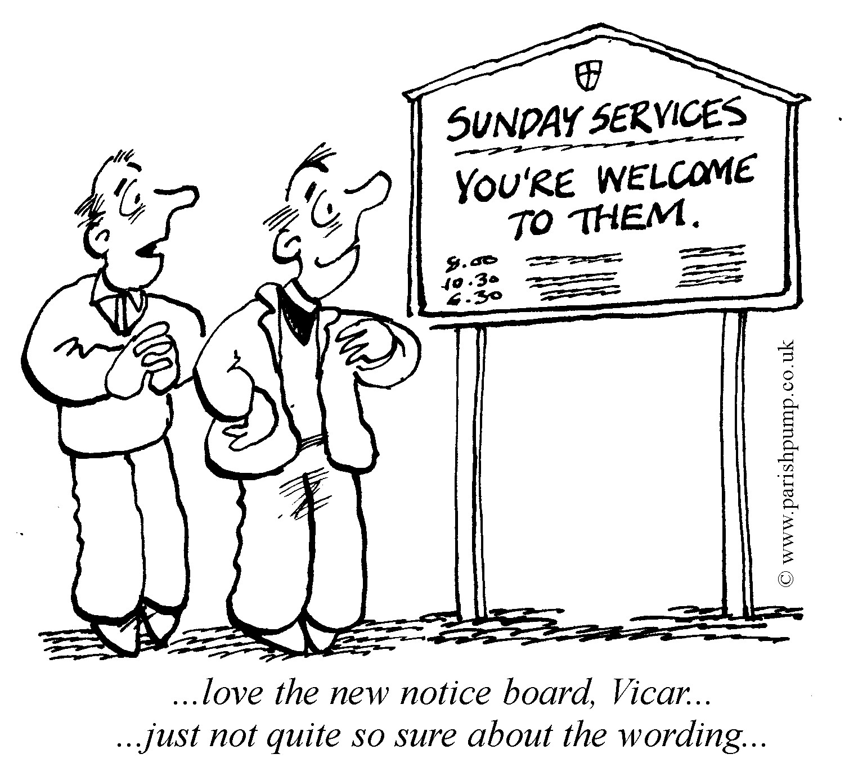

A Prayer from a recent service
Worship is the doorstep of Heaven
Where the children speak to their Father
The poor sit at table with their Saviour
And the weak are empowered by God’s Spirit.
This is where Love and Mercy meet
Love and Obedience hold hands
And where Love bids us welcome
For this is the doorstep of Heaven!

Traffic Problems
Marlpit Hill Baptist Church stood for over a hundred years in Hilders Lane, right opposite where David and Sue Sayell live.The main doors opened directly on to the road. This was not a problem when it was built in 1888 but with the increase in road traffic parking was a problem on occasions.
I was taking a funeral service when I became aware of a commotion at the back of the church. There was an irate bus driver who couldn’t get past the church because of a parked car. Someone brought me a piece of paper with the car’s registration number, so I stopped the service to read it out.
My wife stood up! It was our car!
Gary Bradford.

Photo taken at Guildables by Shirley on her morning walk!
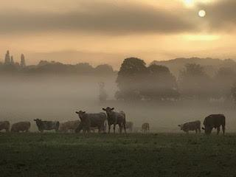

Open House
On March 2nd, Marsh Green’s “Open House” met for the first time. We have aimed to introduce a regular, home-group type of meeting but, as our name implies, a gathering at which anyone is welcome to drop in as the mood takes them. In the early months, the four of us who came up with the idea are taking it in turn to lead a session, in rotation, although we much hope that other attenders will volunteer to take a turn in leading in time.
Meeting fortnightly, between 7.30 and 9 on Thursday evenings, in the home of that evening’s leader, we start by taking a few minutes to draw us all together, ideally in light-hearted fun, and often with an ice-breaker such as: What is the best thing you’ve ever eaten? or Which song is in your head right now? (not necessarily a devotional one!). We then turn to Bible study and discussion, referenced back to the previous Sunday’s service, trying to tease out key messages for ourselves as individuals and for our church and the wider community, through a combination of reflections by the leader, listening to God and the sharing of thoughts.
Thereafter, we pray together, for people and situations attenders suggest, whether from their immediate experience or further afield, including overseas. Not least, we pray for Marsh Green church, that our whole church fellowship will discern God’s vision for its role and mission and – equally importantly! – help us to achieve it.
If you would like to come along one Thursday evening, we should be delighted. You can find the location and date of each get-together in the Marsh Green church weekly news-sheet. In the meantime, sending the best of wishes to you all for a Joyful Easter.
Hilary Brand, Peter Brand, Sue Rowe and Marion Shoard

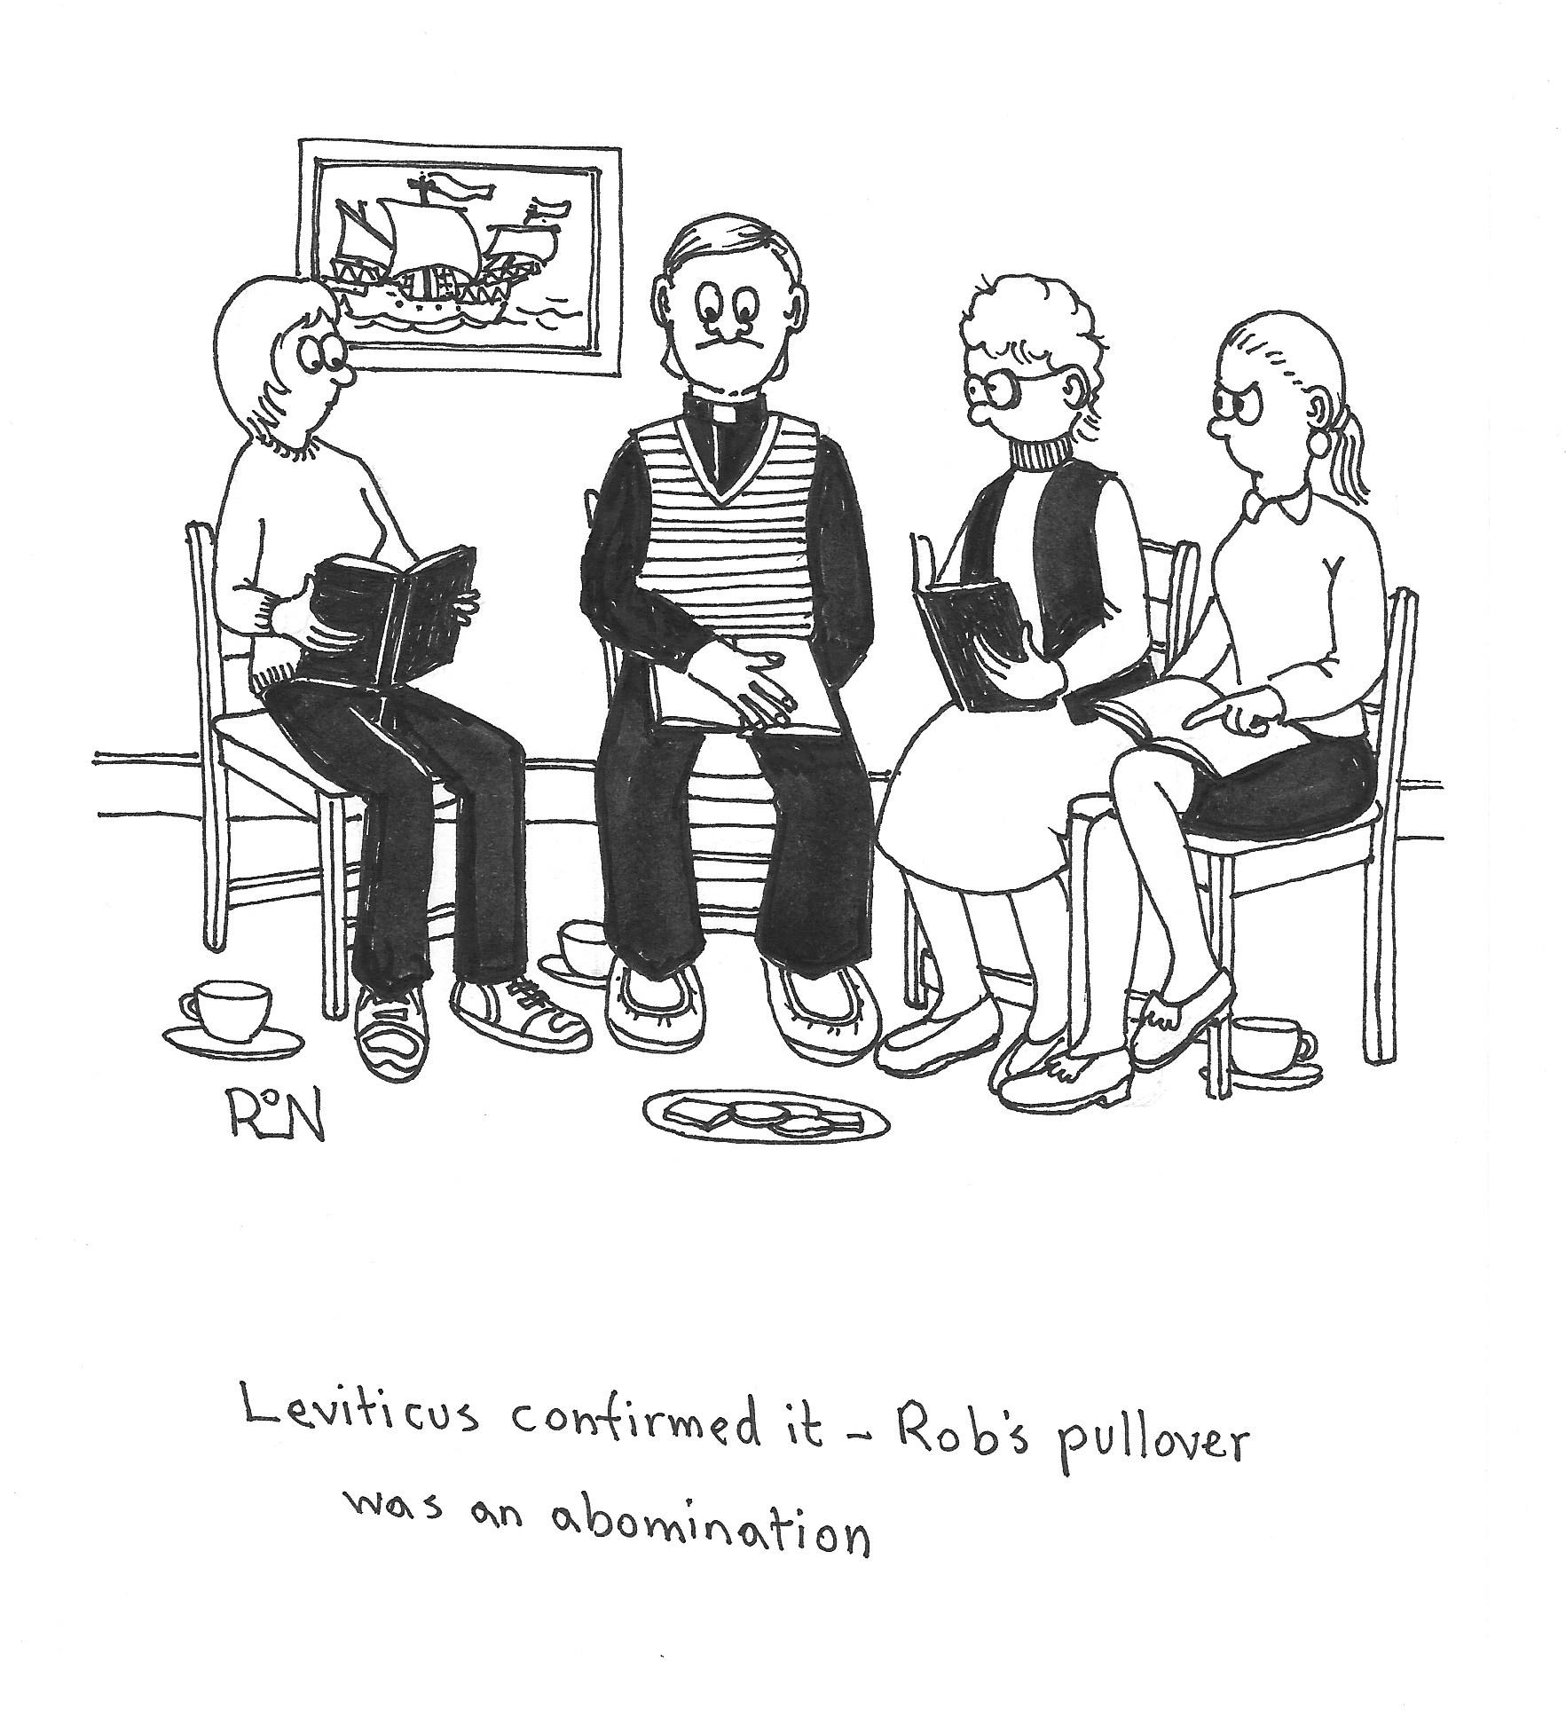

Zimbabwe
I felt our Marsh Green service on 26th Feb didn't tell us much about life in Zimbabwe, so I thought I'd try and fill in a few gaps.

Hilary and I have visited central Zimbabwe on several occasions and every time the overall feeling has been their enormous generosity to us in spite of their material poverty. One time we called on some total strangers to film a woman carrying a pot on her head, and as we couldn't stay long enough for them to prepare a meal for us, they gave us a live chicken and some vegetables to make up for the loss! (We gave them to the bishop we were staying with!)

During church services, their giving is not limited to money, it can include window frames (for some building work the church was doing) and even the blessing of a new cooker! Once we saw the stewards taking the collection dancing down the aisle balancing the offering baskets on their heads!
The money is used to buy many things we might be surprised by: pigs, cows, chickens and even building materials to supply local needs. We saw the youth group making bricks to build homes for a priest. There is a definite 'we can do this' attitude!

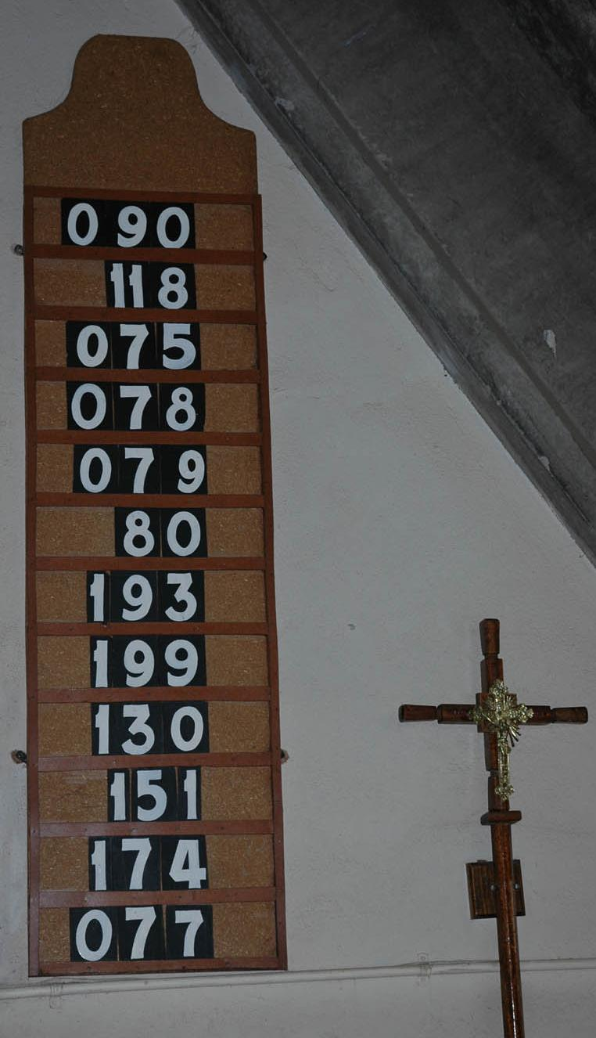
Sundays are special. Many people will have walked for miles to get to church and they don't want too short a service! Two or three hours is not unusual! And they certainly make a joyful noise to praise the Lord! Wonderful harmonies in the singing, accompanied by various shakers and drums. For many of the songs, the rhythm is naturally accompanied by movement or dancing. The children stay in for the whole service, drinking in the spirit of the worship.

I videoed an outdoor service at a local hospital. If you want to get a flavour of the worship, you can see an extract on YouTube.

The last time I checked, it had been viewed 169 thousand times!

https://tinyurl.com/4jubj458

And afterwards, it's a meal before going home. Usually sadza, a sort of solid maize porridge dipped in gravy, cooked over an open fire, which they eat sitting around outside.

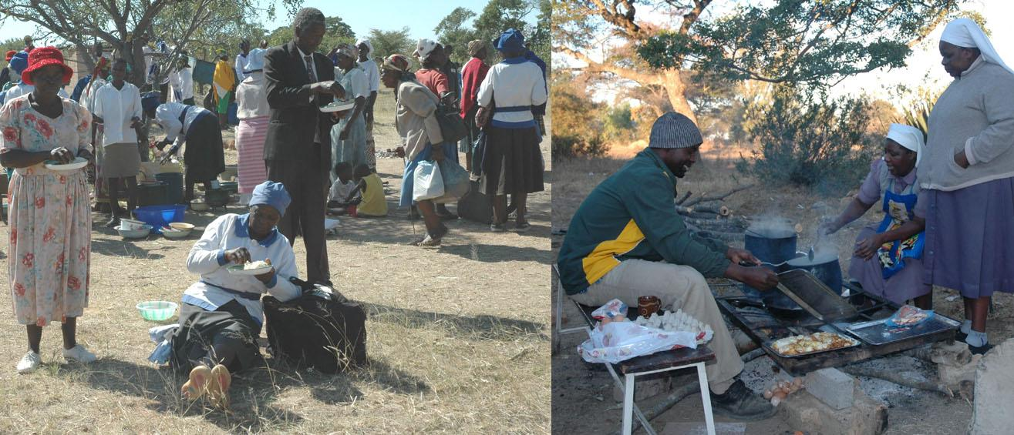

Life in Zimbabwe is not easy. The unemployment is not as high as it was, and the inflation rate has fallen. It is now only around 200%! And with elections coming up later this year there is fear that violence will again be used to intimidate voters.

But our overall image of the people we met in Zimbabwe is joy, as shown by their smiling faces!

Peter Brand

ICE

This is not an article for the golden oldies among us about taking care in the snowy weather we are due to have as I write this. ICE in this case stands for In Case of Emergency and is an initiative designed to provide medical and, sometimes, next of kin information to first responders (ie police, paramedics and firefighters), medical professionals and others in case of an emergency.

Following an incident in our church we have already taken a first step towards ICE by introducing a paper list of emergency contact details for those who want to be included. This is kept in the vestry so we now know who to contact in case of an emergency for anyone on the list. Do feel free to add your name if you wish.

Technology can also help those with newish mobile phones to carry this information with them everywhere. So we thought it might be helpful to explain how it works and how to set it up.

The idea is that first responders etc can access the information without your help and knowing your password or PIN. And they cannot access any other information on your phone. What follows is a non-techie's step by step explanation of how to do it so apologies if it's a bit clunky. Also different Android phones will be different and as they update regularly the detail of screens/icons will change. If these steps don't work for you, try asking me or, probably more successfully, a six year old.

The icons (labels on your screen) you need to press are shown below in bold.

FOR APPLE PHONES

- Open phone with password
- Go to health icon (white with a red heart – see photo) and select
- Select Medical ID and then Review medical ID data
- Fill in the form with your details eg medical conditions, allergies, medications, blood type, organ donor status.
- You can also link to contacts for Next of Kin information

All these details will be visible to first responders without opening the phone.

For Next of Kin, I suggest that you should agree with the person who will be shown that they are happy to be added as a contact and also what detail will be shown eg just mobile phone number. You might need to edit your Contact information to show just the agreed detail. If you want to keep more information in your phone eg address and postcode you might want to set up 2 entries for someone, eg for me BENA1 for emergency contact and BENA2 for other detail like post code.

FOR ANDROID PHONES (BASED ON A SAMSUNG GALAXY)

Open phone with password
- Go to Settings and scroll down to Safety and Emergency
- You can then fill in Medical info and Emergency contacts
- The detail is much like Apple ie key information like medical conditions, allergies, current medications and blood type but does not seem to include donor status.
- It also gives the names of any emergency contacts you have listed but not their contact details.
If you Google ICE (avoiding the Institute of Civil Engineers) you can buy many other ways of holding this sort of information online such as Medical ID cards and a Disc Holder for your windscreen for paper based information started by someone in Kent.

If you are nerdy enough, like me, to look on Wikipedia you will see that there is some disagreement about the usefulness of this approach. In summary, the jury's out so far but they don't mention any actual downside to the individual. It recommends carrying something on paper in your wallet - written by a man perhaps and not much use if your chest is covered in blood. It's up to you....

MAKING EMERGENCY CALLS FROM YOUR MOBILE PHONE

We thought it might also be helpful to cover how to make 999 calls in an emergency.

APPLE

To call emergency services on an iPhone 8 or later, follow these steps:
- Press and hold the button on the right side of your phone, along with one of the volume buttons on the left side of the phone.
- An 'Emergency SOS' slider will now appear. If you drag your finger along this slider, you will call the emergency services. If you keep the buttons held down but don’t use the slider, a countdown will begin and an alert will sound.
If you use this Emergency SOS function Apple also sends a text to your emergency contact automatically.
ANDROID
If you need to make an emergency call and don't have time to unlock your phone, switch it on and swipe up on your screen to be taken to the Lock screen. Then tap Emergency call to call the emergency services.
Your phone really is your friend in emergency circumstances. For example with Apple you can also set up a feature where, if you press the side button 5 times quickly, a countdown will begin and an alert will sound. And with Android you can set up different ways to Send SOS messages under the same Safety and Emergency section.
Barbara Riddell

Some characters from Marsh Green history
Tom Knight the drover
Tom Knight, a resident of Marsh Green, was described in 1912 as ‘the last inhabitant of Edenbridge who still wears a smock’, and the Eden Valley Museum still has his smock today. Tom was a drover, driving herds of cattle and sheep to and from Edenbridge market and to new pastures, walking long miles on England’s country lanes.
It seems that Tom played an incidental part in the beginnings of the Marsh Green church, when a local doctor called Sydney Austin saved Tom’s life and was somehow so moved by the experience that he felt compelled to preach the gospel to the local community in an open air meeting in 1878. The meetings became regular and so well supported that they were an influence in the decision to build the Marsh Green church.
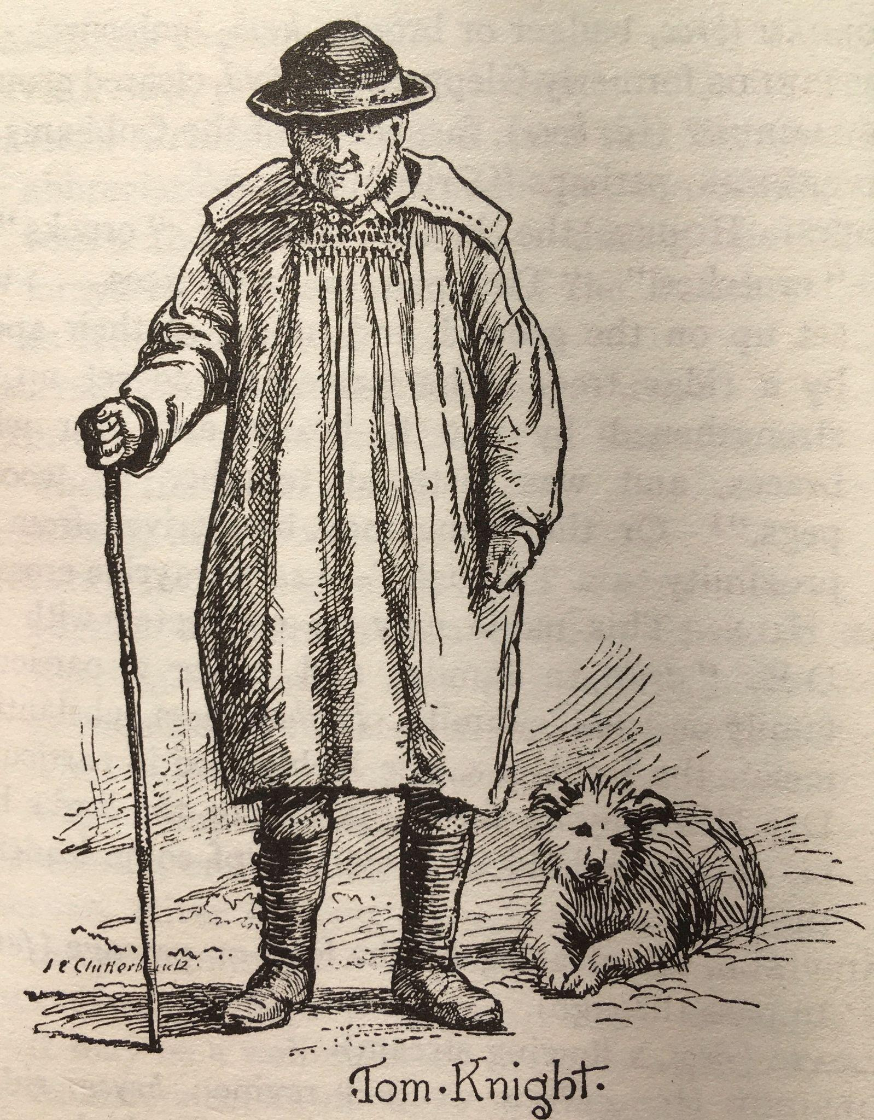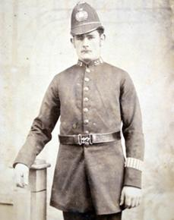

The Hickey family, Irish migrants
The middle of the 19th century saw an influx of Irish labourers into the area, driven in desperation by the Great Irish Potato Famine. One of these, James Hickey, found work on nearby Haxted Farm and moved with his wife Margaret and family into Marsh Green.
They did not receive a warm welcome. In July 1851, James got into an argument with a local man, probably James Betts. A week later, Betts with a gang of over 30 others arrived outside the Hickey’s house, and demanded James come out, ‘or they would kill the Irish *****.’ James wisely stayed inside, but the rioters remained for two hours shouting and throwing stones till all the windows of the house were broken. When a nearby farmer came to remonstrate with the rioters Betts told him ‘Damn your eyes, you employ Irish too, don’t you?’ and threatened to come and burn his home and farm as well.
Five of the rioters were arrested, convicted of unlawful assembly and assault and sentenced to six months hard labour. The judge called it ‘an abominable offence’.
Some harmony was later restored when the Hickey’s son, John Francis, married the sister of one of the convicted rioters, Francis Divall. John Francis became a police constable, while Divall became landlord of the Wheatsheaf, dying at the ripe old age of 85.

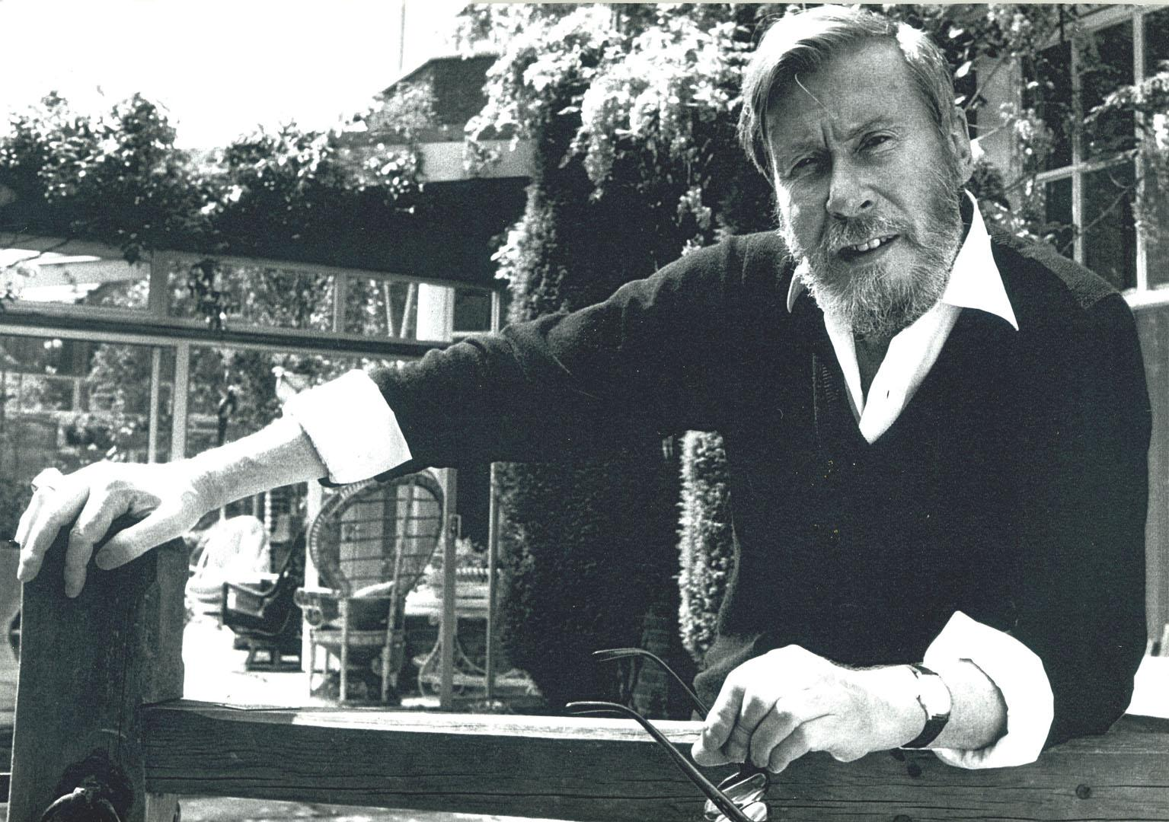
John Osborne, the ‘angry young man’ turned country gent
John Osborne was the first of the ‘Angry Young Men’ playwrights of the 1950s, with his most famous and semi-autobiographical play ‘Look Back in Anger’ labeled as ‘kitchen sink’ drama. By the time he came to the Eden Valley he had a very different lifestyle. He lived at Christmas Place just south of the village between 1967 and 1986, where his summer show-business parties became legendary. He shared the home with the last two of his five wives: the actress Jill Bennett, a relationship that descended into mutual loathing, and then with journalist Helen Dawson, probably the happiest ten years of his life. He wrote no plays there, but two acclaimed autobiographies: ‘A Better Class of Person’ and ‘Almost a Gentleman’. Hilary Brand

Traidcraft RIP – long live Fair Trade!
After 44 years of successfully pioneering efforts to combat injustice in trade and poverty, by finding markets for small farmers and craft workers throughout the world, Traidcraft plc is now in administration - another victim of global economics, the pandemic, the war in Ukraine, high energy and transport costs. Despite the heroic efforts of the team at HQ in Gateshead, the final blows were low consumer confidence last autumn and the uncertainty created by Royal Mail strikes in December. The Board of Directors decided with tremendous sadness to close the business, leaving Traidcraft’s charitable arm, Transform Trade (formerly Traidcraft Exchange) to carry on the vital work of supporting small producer groups, fighting for transparency in trade, and modelling how to do business in ways that protect the rights and dignities of suppliers throughout the world.
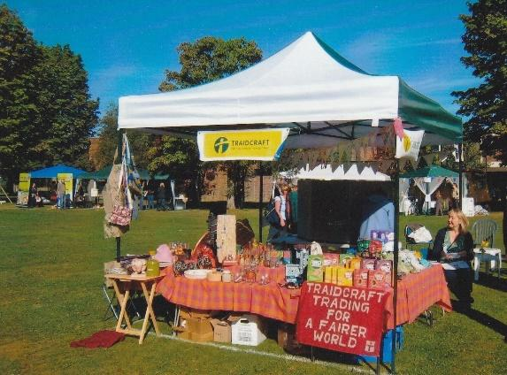
Traidcraft plc was founded in 1979. In Edenbridge, early Fairtraders Pat and Paul Oliver sold products from their garden shed! In 1984 the Olivers handed over to a group of young mums who established Edenbridge Area Traidcraft with the help of a £200 grant from the Edenbridge Churches in Covenant. Traidcraft stalls popped up at the back of churches, at village fetes, and at BRIDGES. As momentum grew, the whole town supported EAT’s annual Traidcraft pre-Christmas pop-up shop in the High Street, which inspired EAT’s long-running monthly Fair Trade Box scheme! Profits were given to Traidcraft Exchange and local charities - Eden Christian Trust and BRIDGES.
In 1994 the Fairtrade Foundation (launched by Traidcraft and development charities like CAFOD and Christian Aid, the World Development Movement and the National Federation of the WI) launched its Fairtrade mark – a licensing system guaranteeing that the price producers received for their products was not only fair, but included a premium for them to spend on improving their local community facilities. These included schools, irrigation systems, bikes, training - whatever they most needed to build sustainability and keep people from drifting into poverty.
In 2005 Edenbridge succeeded in becoming the first Fairtrade town in Kent, with commitments from the Town Council, schools, churches, BRIDGES, Scouts, Guides, the Co-op and many businesses to promote Fair Trade in all their activities. As the Fairtrade mark spread from bananas and coffee to tea, chocolate and many other products, Fairtrade Fortnight became a local celebration, which thankfully our supermarkets continue to feature each year.
Traidcraft’s Fair Trade pioneers have raised ethical standards in business, inspired Shared Interest investment schemes that loan capital for people to trade their way out of poverty, and combatted the exploitation of workers – modelling transparency in business relations which has now been enforced in law. We have much to thank Traidcraft for, but the mission to combat trade injustice and poverty goes on. Producers of cocoa and coffee, bananas and tea are all at risk of losing their livelihoods from the changing climate in tropical regions, so please don’t ignore the Fairtrade mark in favour of a cheaper option on the shelf – value these luxuries, and give their producers their real worth as our neighbours in a changing world! That will be Traidcraft’s true legacy.
Gill Musgrove
2023 World Day of Prayer
On Friday 3 March members of St John’s joined in the 2023 World Day of prayer service, held at the Eden Church as part of a huge wave of prayer which circles the earth for at least 38 hours. It began at dawn in Western Samoa and Tonga in the Pacific Ocean and ended at dusk in American Samoa when you were having the next day’s breakfast. Isn’t it amazing to be part of something so huge. That’s what makes the day of prayer so special.
Each year the service is written by the Christian women of a different country. This year it was the turn of Taiwan, a country which has for many years been caught in a superpower struggle. Taiwan was part of China until at the end of the Chinese civil war in the 1940s the Chinese Nationalist Party, which had been defeated, held on to the island of Formosa and were protected by the USA during the Cold War.
Now the overwhelming majority of UN member states, including the USA, have diplomatic relations with China rather than Taiwan and the UN itself recognises China, and not Taiwan,as the sovereign state. But the USAstill guarantees Taiwanese self government, while China has always regarded Taiwan as still part of China (rather as it did with Hong Kong before the agreement with the UK to hand it back) and has been making increasingly threatening noises towards Taiwan on a daily basis. So although China does not actually outlaw Christianity (and your editor on a visit to China some years ago was surprised on a Sunday morning to hear church bells ringing across a Chinese city and to trace them to a large church which was crowded full) nor does it promote it and the Christian people of Taiwan are much in need of our prayers at this time.
The worship service includes letters of encouragement for women who face suffering and injustice. These stories of faith focus on issues that are shared by women and girls around the world and that continue to challenge us to prayerful action.
We thank the Christian women of Taiwan for this year’s service and pray that our response will be affirmative and constructive as we commit ourselves to positive prayerful action.
Submitted by Sue Rowe. Edited from the original by Alan.

I was not always as I am A POEM TO END!
Astute but vague.
Unfocused. Mild.

I once was hurried
Acute. Angled.
Foot tapping.
Sharp.

I know you think that I am old.
Confused. Uncertain.
Needing help.

But I just need to concentrate.
While being happy I'm retired.
Unhurried. Stress reduced.
Jubilada as the Spanish say.
Sounds like joyful, and it is.

I am still grateful for your help
Even though I feel a fool.
I’m that at maths
YoungToby says.
But not at life.

I am ' still learning
Techno gizmos
New words like woke'

I may be older
slower too.
Sometimes unsure.
Less confident?
I am not quite as I once was

But let’s be clear..

I am not stupid!

Barbara Riddell

